

**WP-II: Mini Project Report**

Batch: A1

Roll No and Name of students in the team:

1814007 – Bhavik Bhatt

1814020 – Muskaan Nandu

Mini Project Title: Book Store

Project Description (introduction, motivation and objectives):



During these tough times, its best to avoid any possible way of going out and getting in physical contact with anyone or anything , but that is no good reason to waste the plethora of time we have got due to the pandemic. Thanks to the advanced technology that we can get what we want online. Thus we came up with the idea of making our favourite books just a click away from us. *BookStore* is an “online bookstore” which allows our bookworms to find their favourite books online. The books are brought to your doorstep, ensuring safety and sanitization. Thus, why wait? Go find your favourite books on *BookStore*.

Scope:

1. Major web Functionalities with description:
2. The starting part of the website is a homepage which allows user to surf through the website and look for the details of their favourite book.
3. To buy a book, a user needs to Sign Up.
4. A Signed Up user can Sign In or remained Signed In whenever they want to a buy a book.
5. We have a wishlist feature which allows a Signed In user to add the books they wish to buy but would wait for a better offer or a better time to buy it.
6. The Add to cart feature allows the Signed In user to add the books they want to buy to the cart.
7. The Check Out feature allows the Signed In user to Confirm their order and buy their books.
8. The Admin Login ensures the protection of admin control features and makes sure only validated admins can make changes to the website data.
9. The admin can Add new books with their details.
10. The admin can Edit the details of the books.
11. The admin can Delete books from the database.
12. Implemented search bar for books on both user and admin side.
13. **Minor web Functionalities with description:**
14. The Contact Us feature allows the user to give us their feedback. The user need not be signed in for this. **(Thus we have used captcha to ensure the user is not a robot and avoid spams.)**
15. We have put social links in contact us and footer.
16. The user can edit their profile, upload their profile picture, contact details and address for delivery purpose.
17. The Signed In Users can view their previous orders in the order history section.
18. The Signed In users can move items from the wishlist to the cart.
19. The user can increase quantity of books in the cart.
20. The user can delete books from wishlist or cart.
21. The admin can view list of all orders.

Output (screen shots of the web pages):

Source Code: <https://github.com/Bhavik-20/WebProgramming-BookStore.git>

## HomePage_All.php

**HomePage_All.php:**

1. On the home page we have listed all the books genre-wise

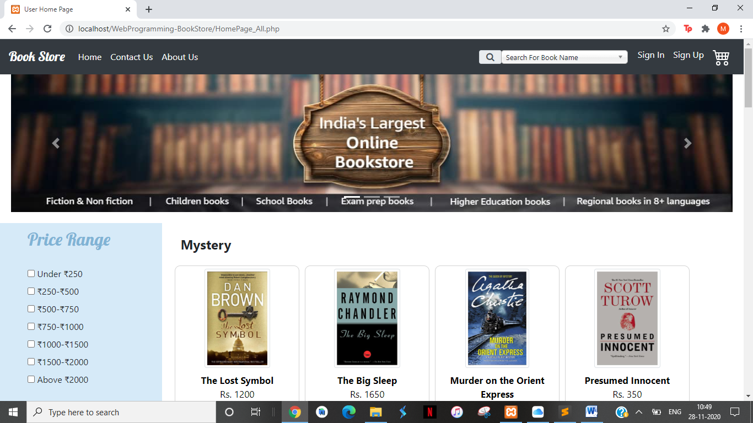

1. We allow the users to apply filers from the left side navbar:
2. Applying filter:

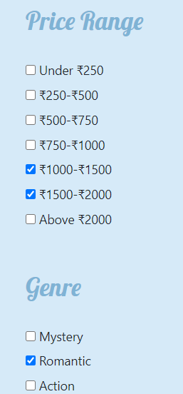

1. Result of filters:

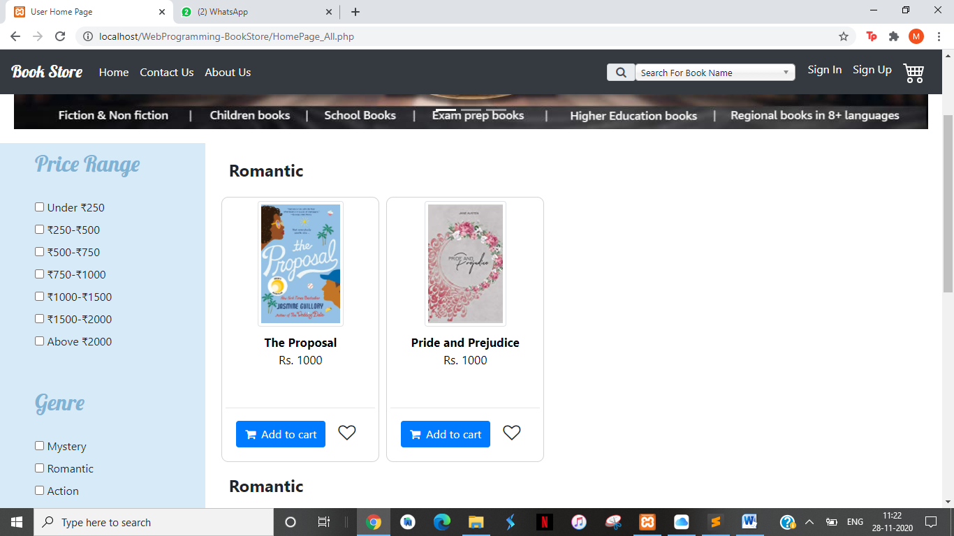

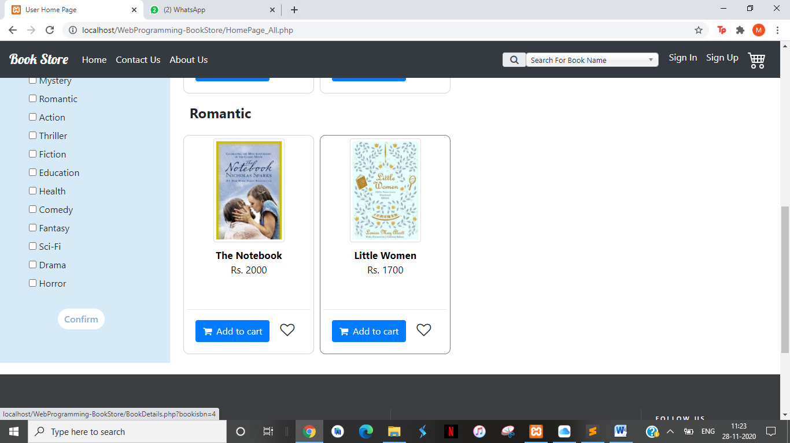

1. On clicking Add to cart / Wishlist or on clicking cart icon in header :

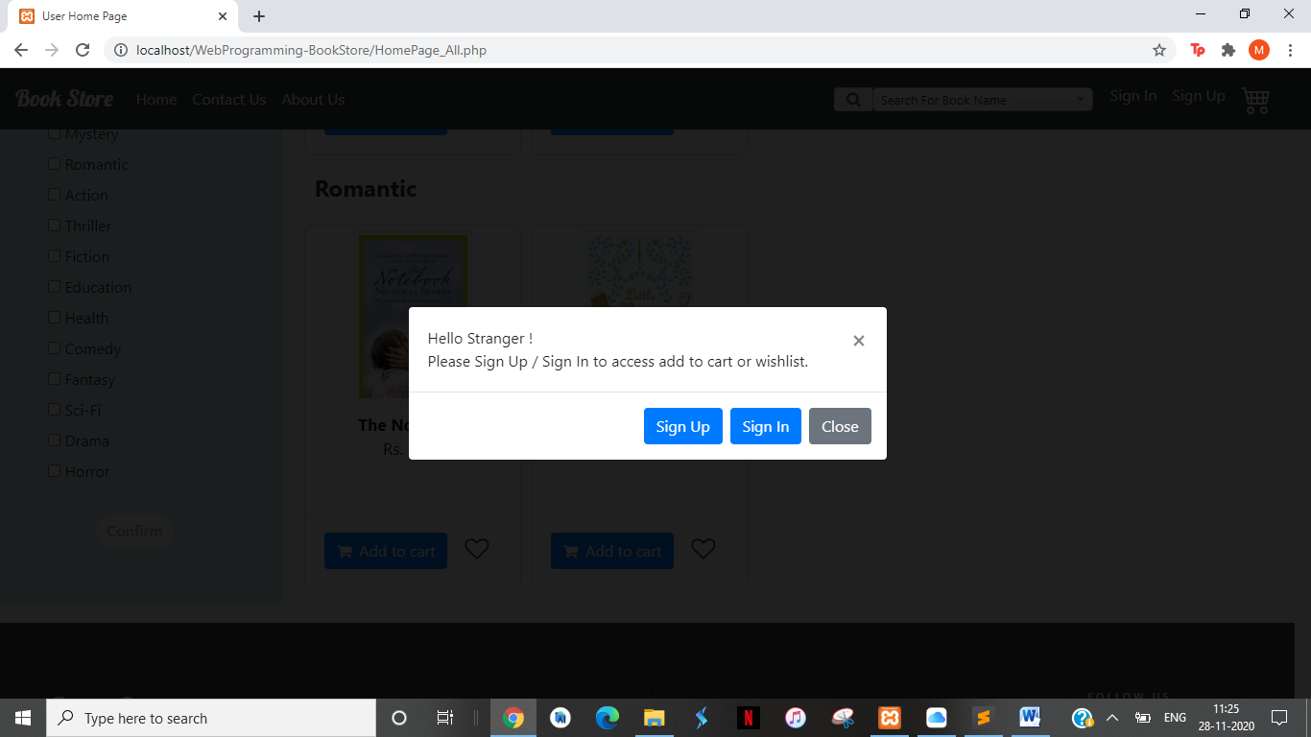

1. On Searching a book:

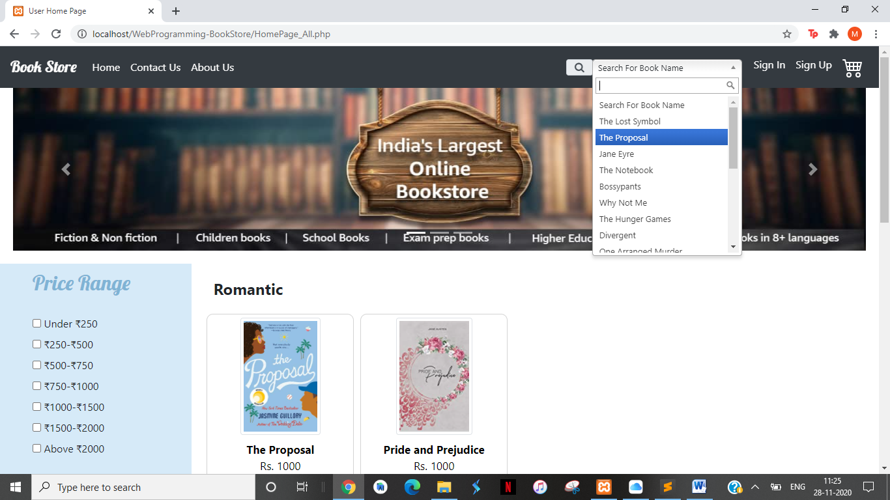 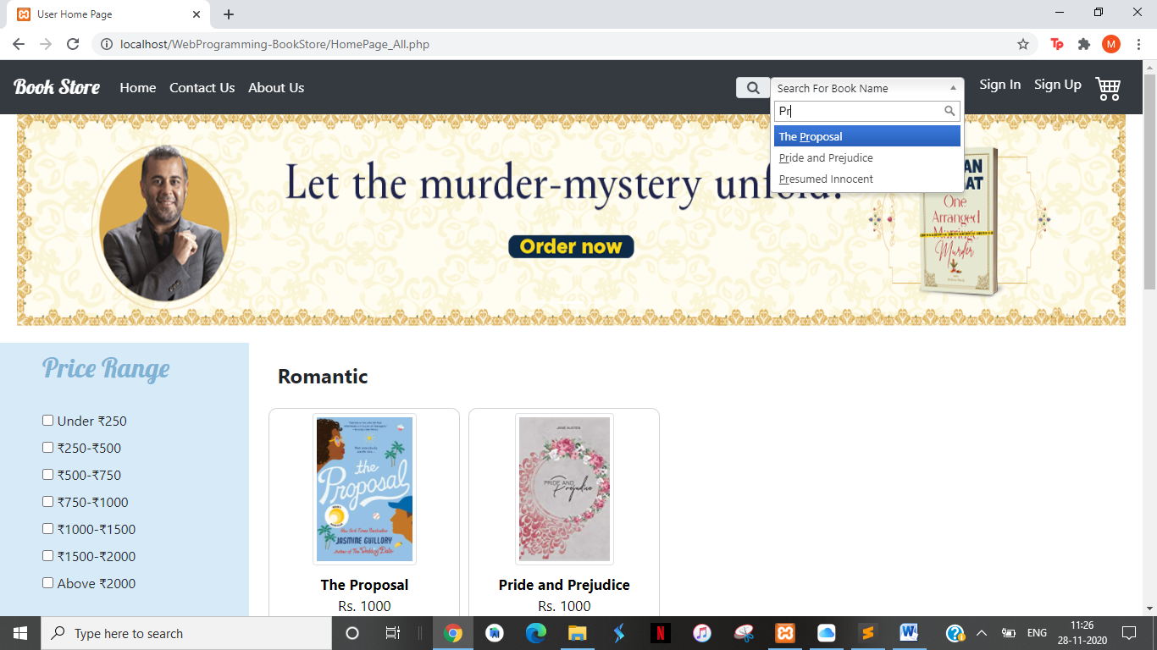

## BookDetails.php

On selecting a book from search results or sekecting a book from homepage we get the book description:

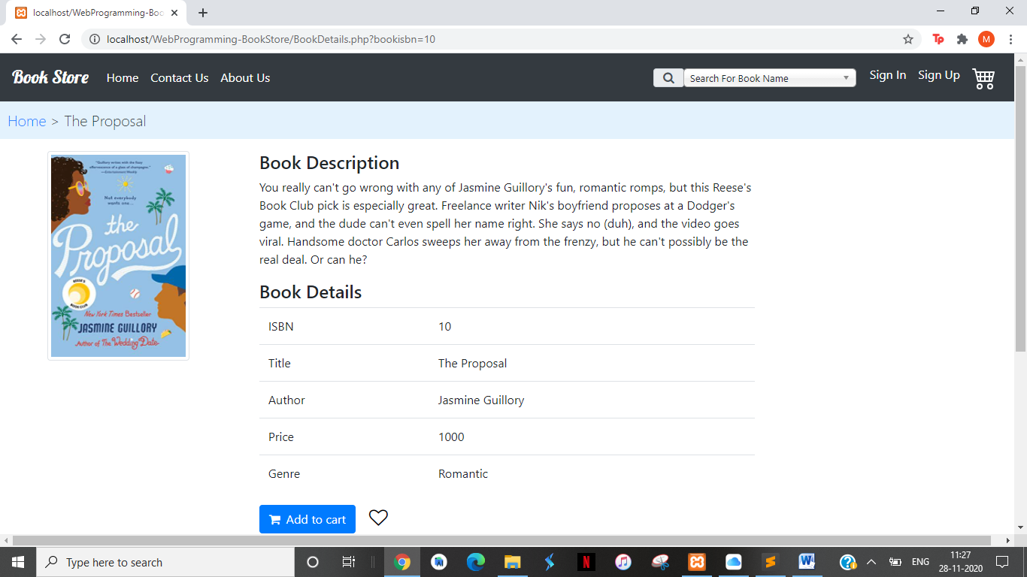

You need to sign up or sign in to buy a book or to add it to wishlist

## SignUp.php

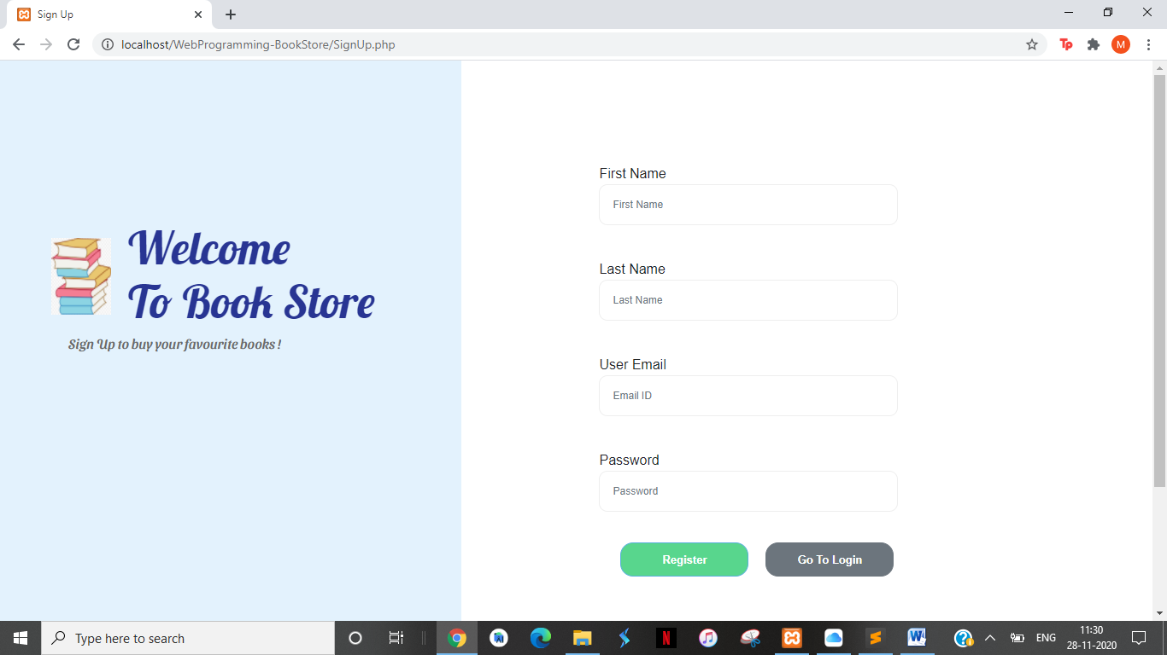

Validation in Sign Up:

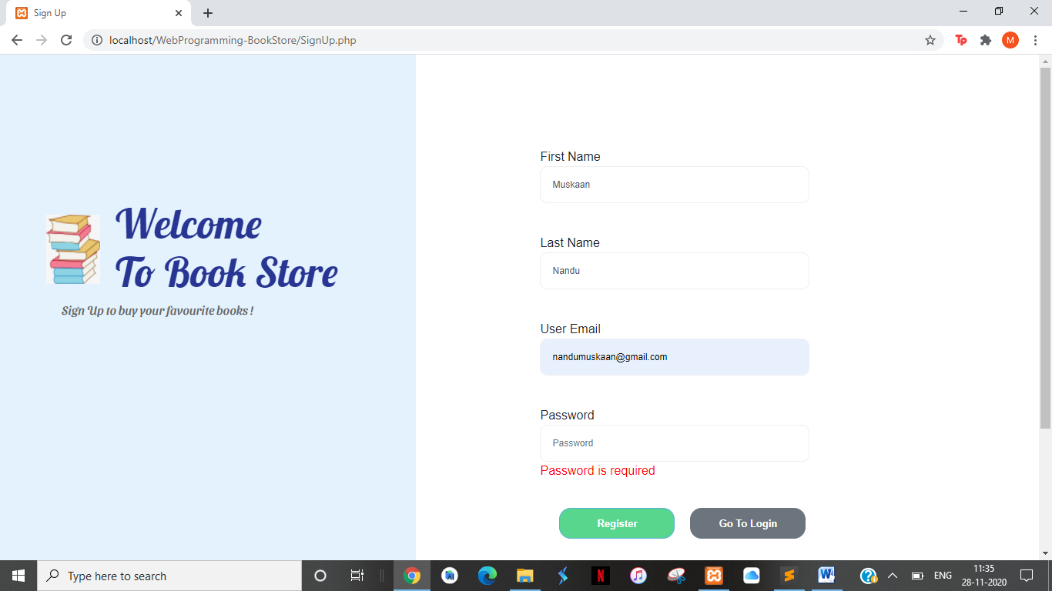

Confirmation Toast:

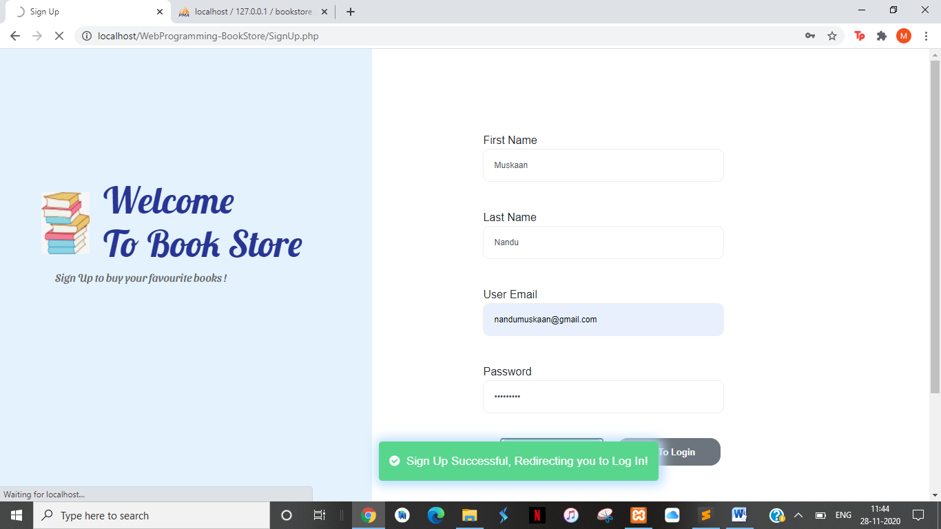

## HomePage_In.php

Validation:

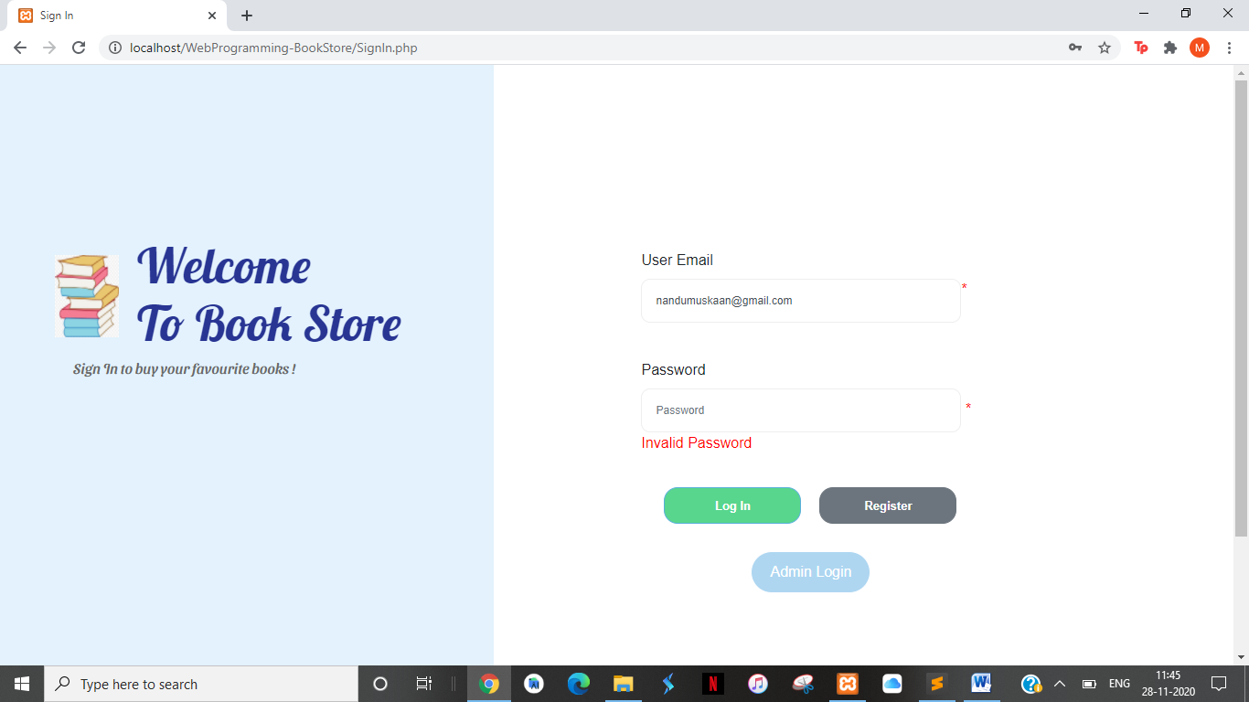

Confirmation on Signing In:

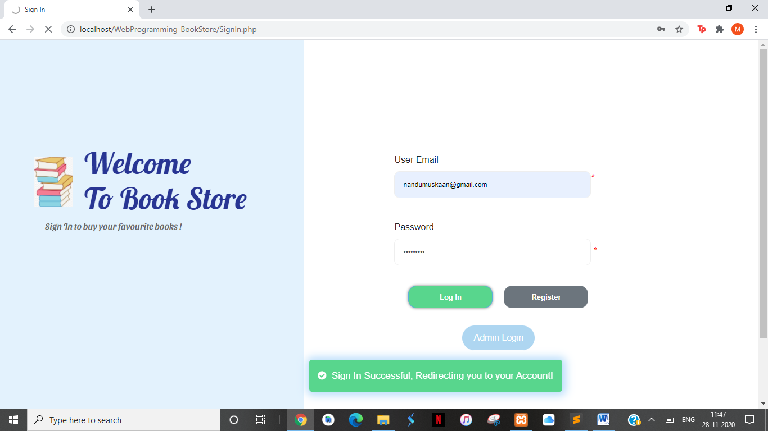

On signing in you go to HomePage_In.php:

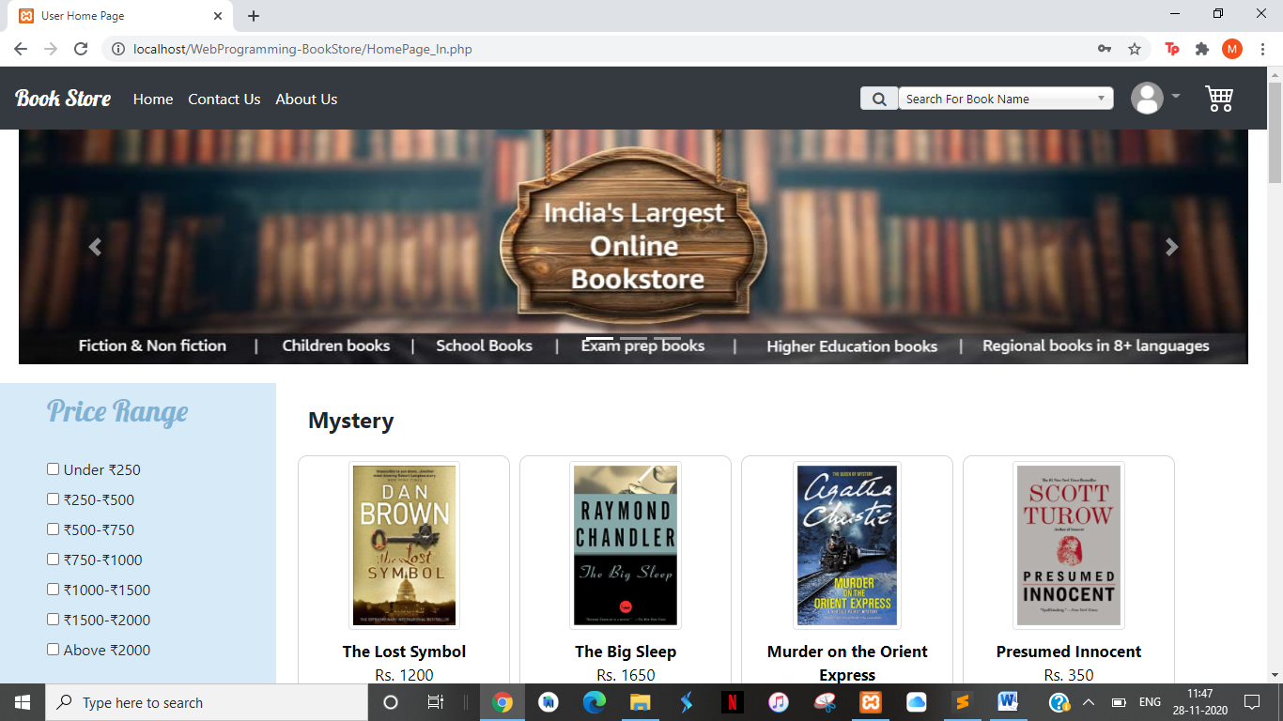

## HomePage_In.php

1. You can perform the same filters and search functionality here as in HomePage_All.php
2. On Clicking any book you are taken to BookDetails.php as in HomePge_All.php
3. On clicking the profile Icon on top a drop down is displayed:

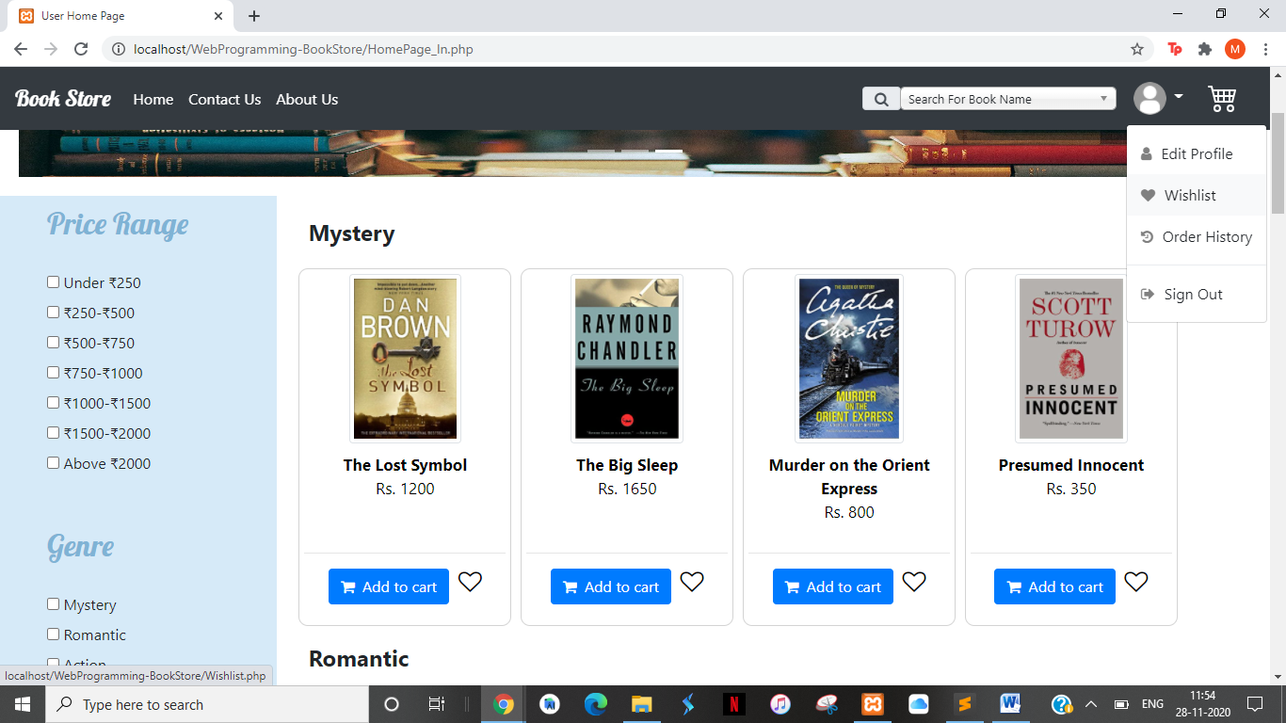

## UserProfile.php

On clicking Edit Profile from the drop down you are taken to Profile page:

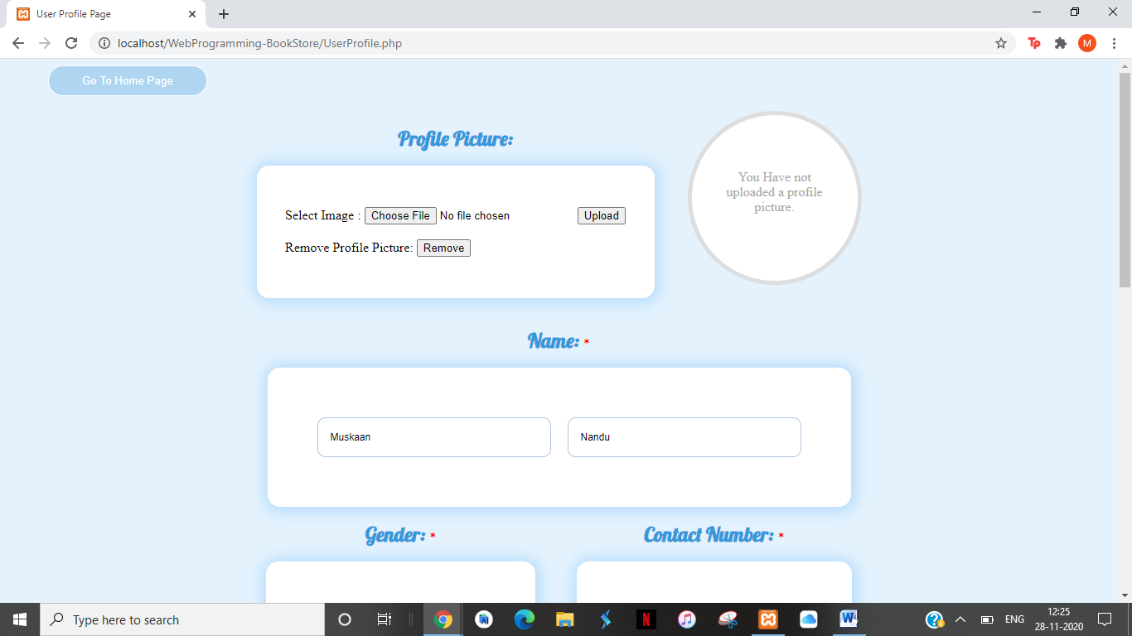

User May add their profile photo and change their details here:

Various validations are applied one of which is:

* Invalid file type for profile picture:



On clicking upload: 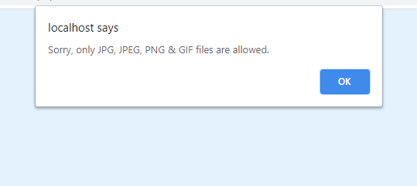

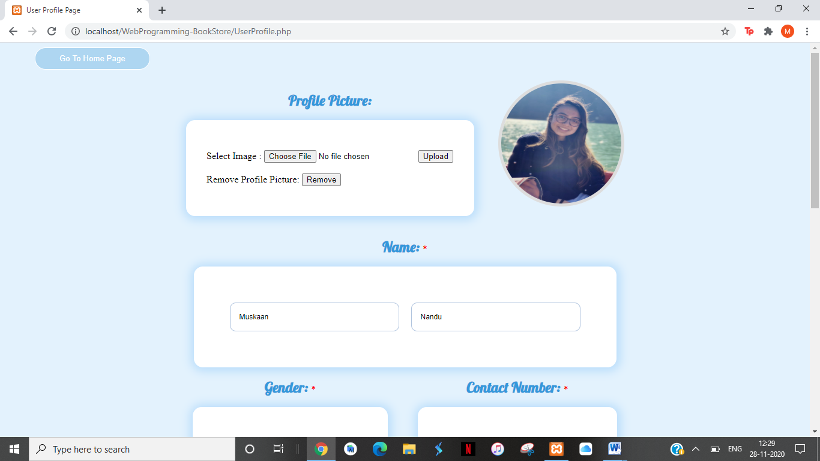

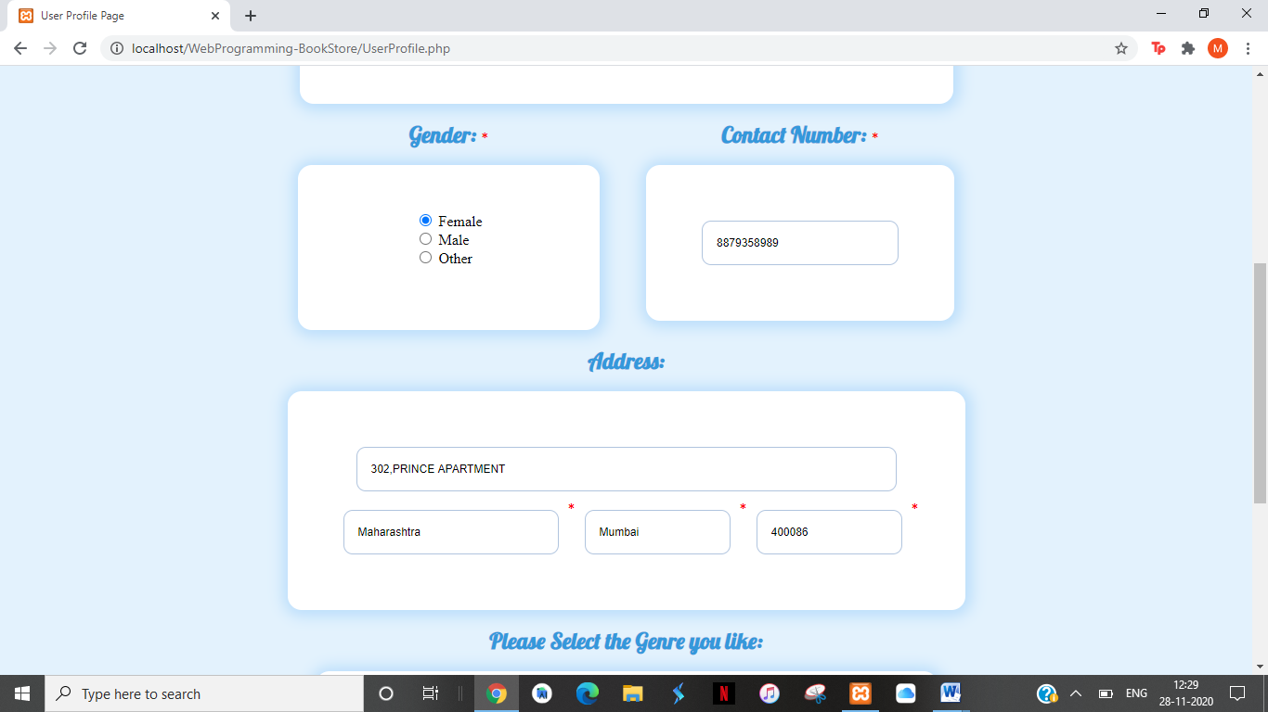

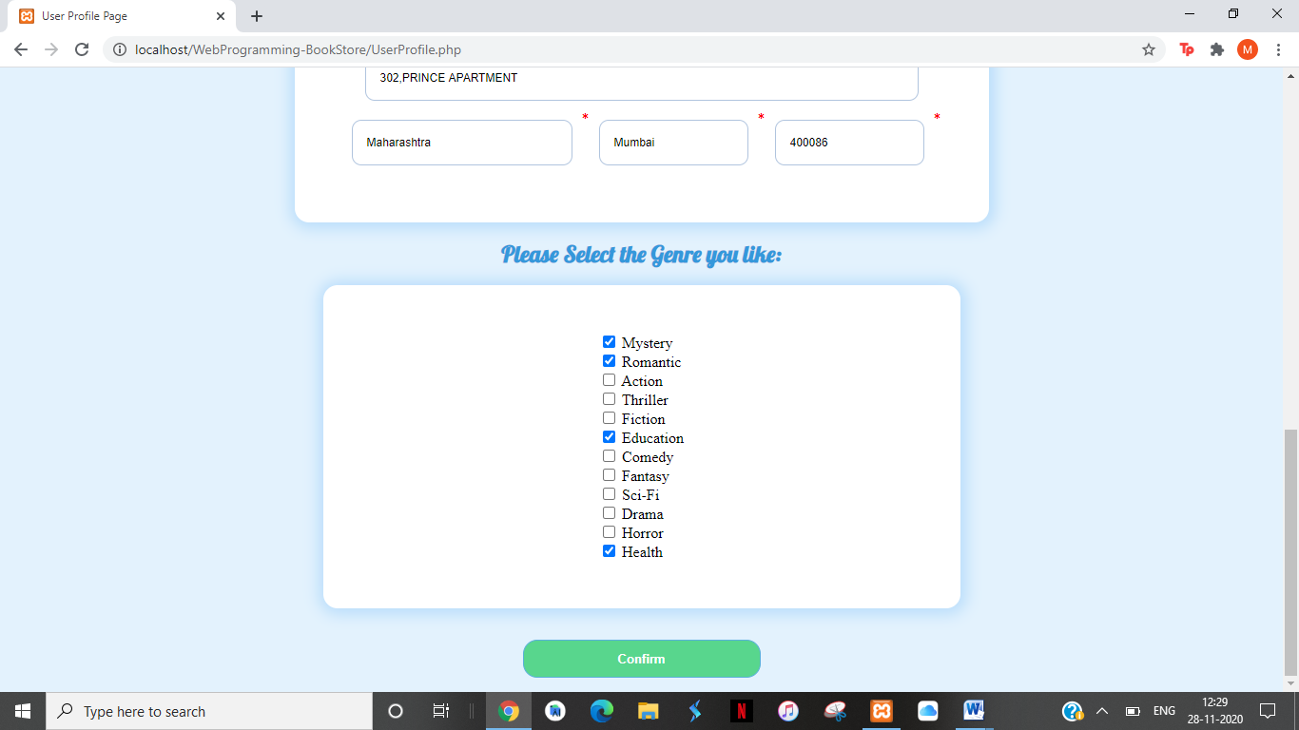

## Wishlist.php

Ongoing to wishlist you go to wishlist:

1. When wishlist is empty:

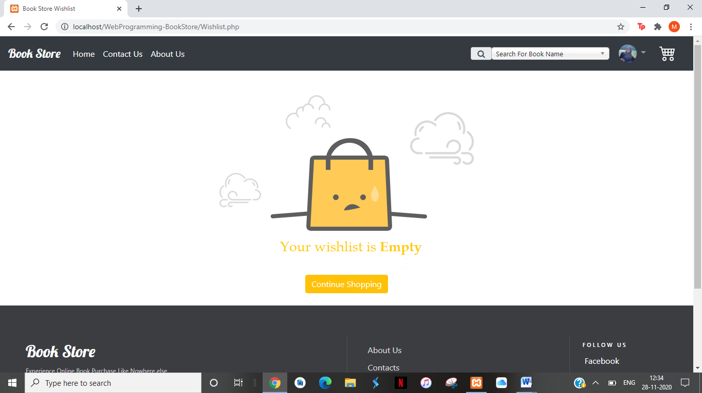

1. On clicking continue shopping you go back to home page.
2. On clicking heart on homepage the book is added to wishlist:

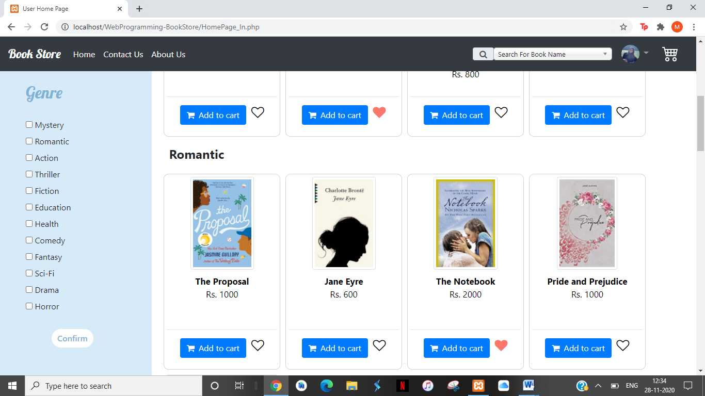

1. On Adding books to wishlist:

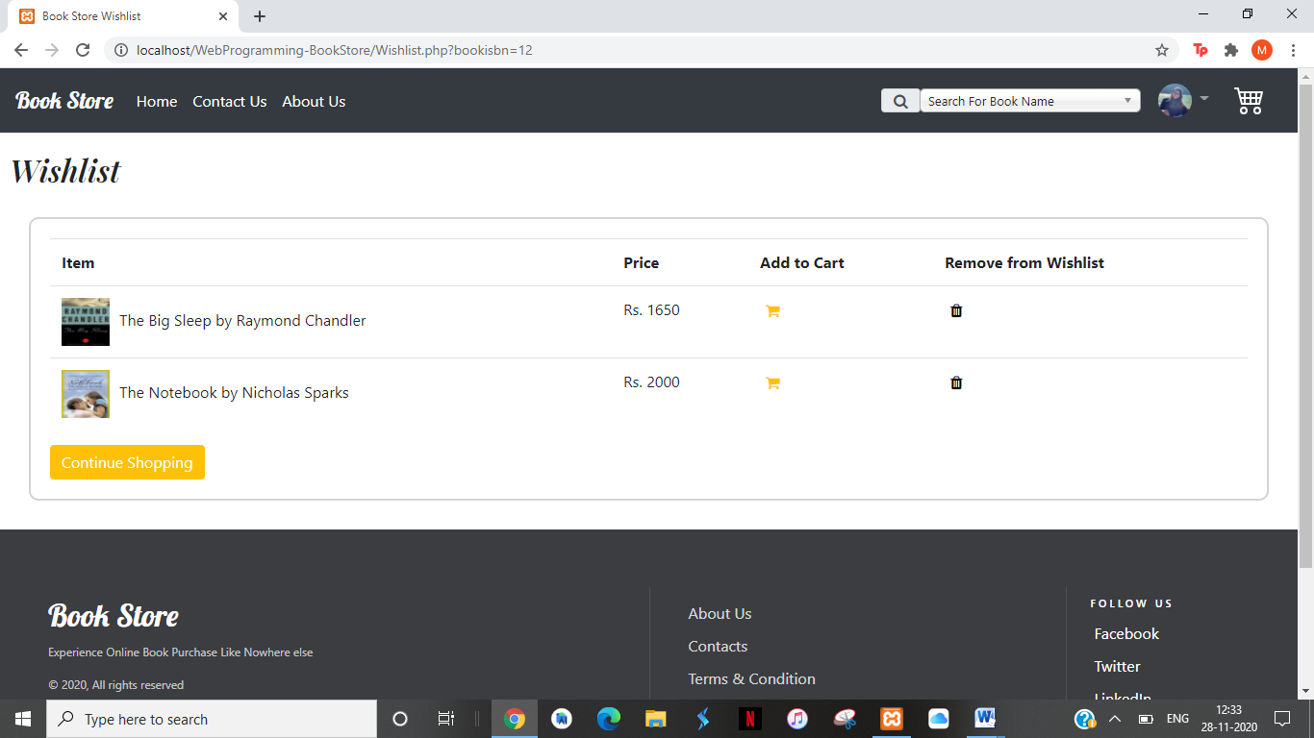

1. On clicking trash icon the book is removed from cart.
2. On clicking the cart icon the book is removed from wishlist and added to cart
   1. Added to cart

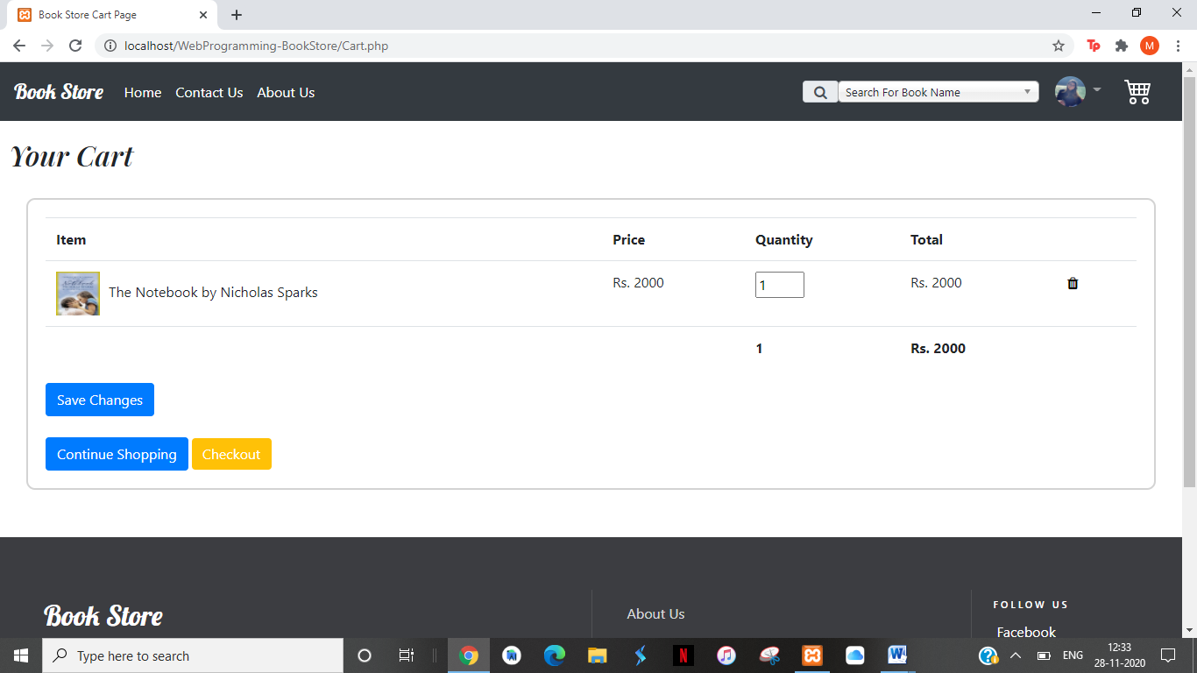

* 1. Removed from wishlist

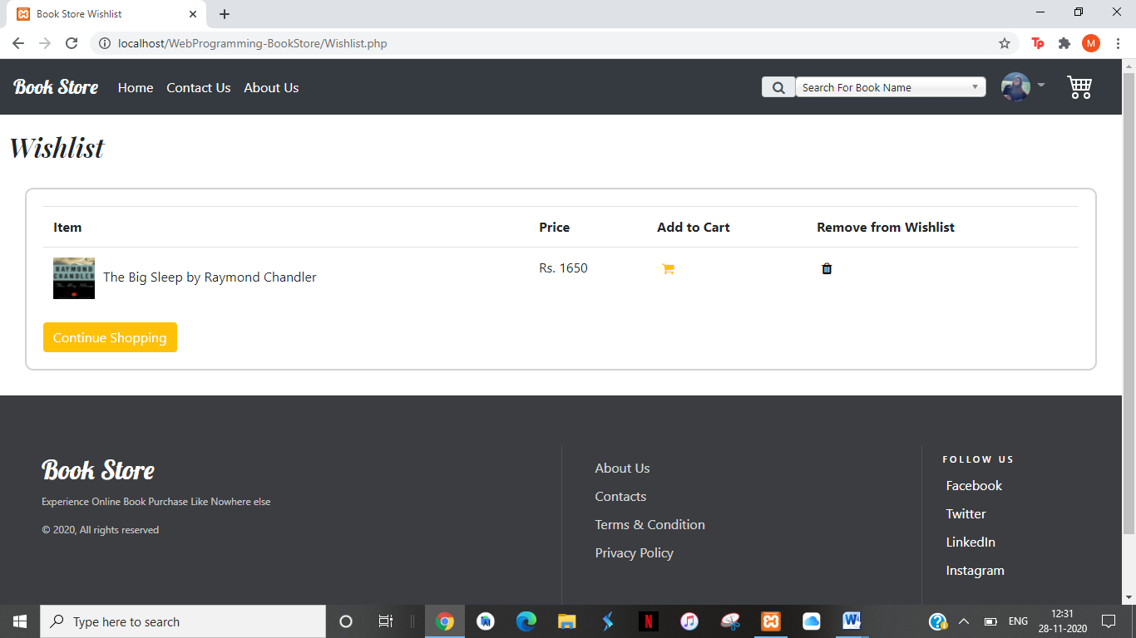

## Cart.php

1. On clicking add to cart or on clicking the cart icon in header you are brought to cart.php
2. When Cart is empty

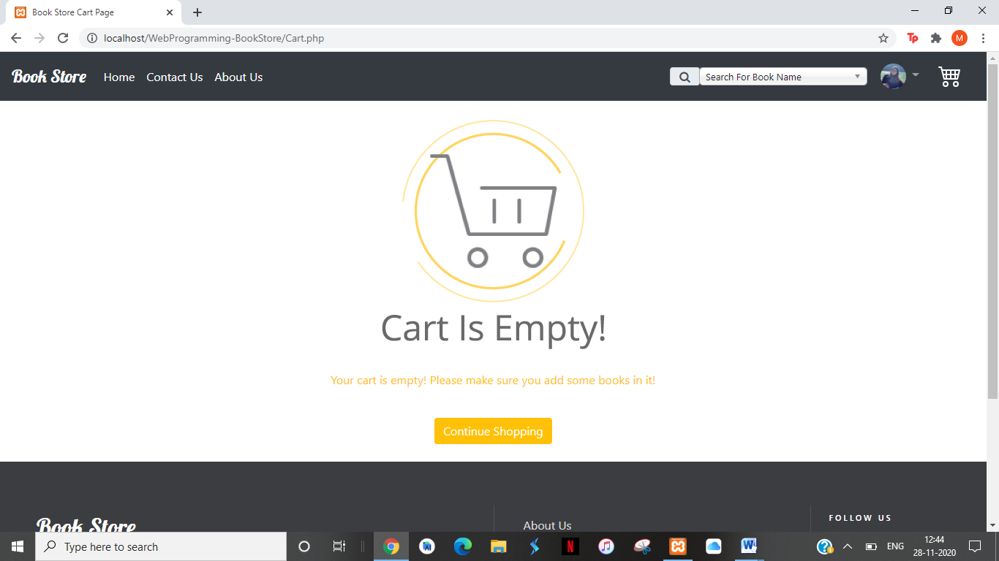

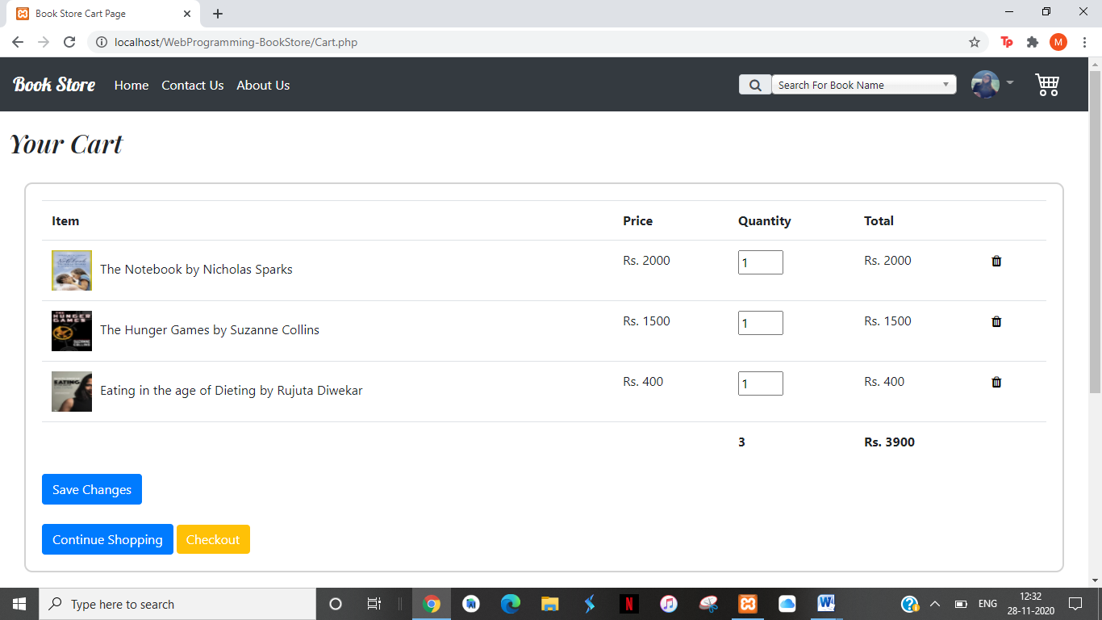

1. You can delete a book from the cart by clicking on trash icon.

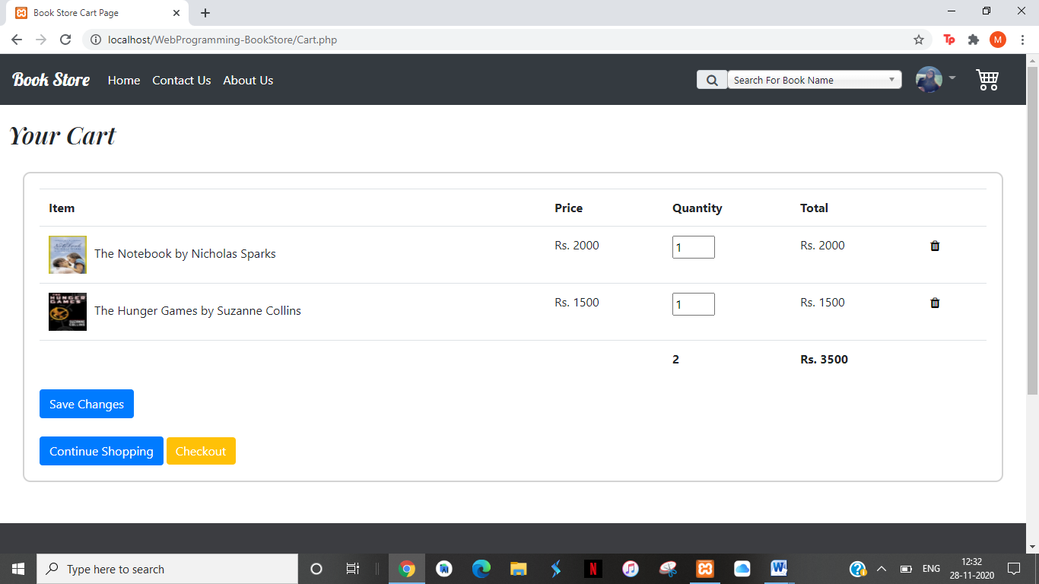

1. You can change the quantity of book and on clicking save changes the total of the book and the grand total changes accordingly.

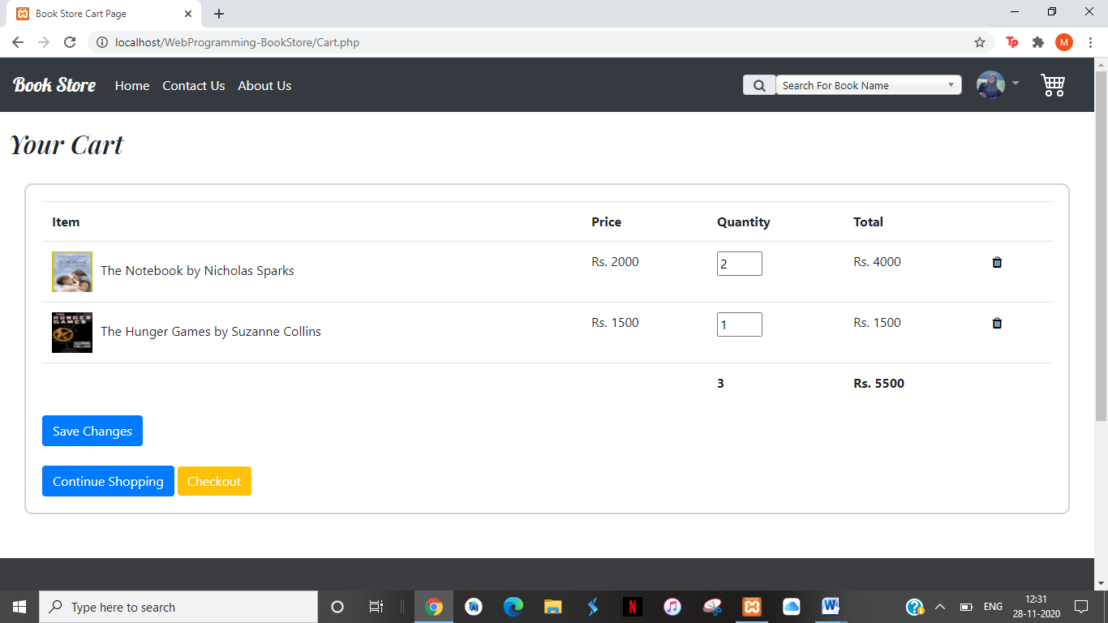

## Checkout.php

On clicking Checkout Invoice is printed :

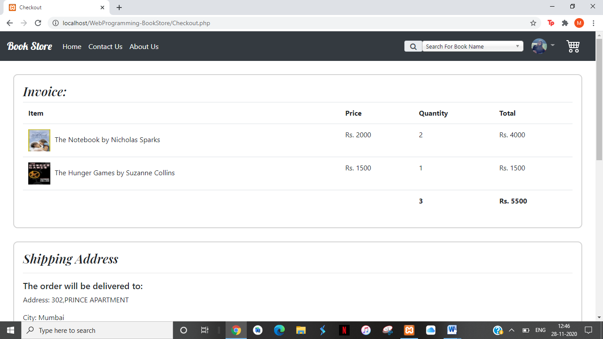

Shipping address and total payable amount is printed:

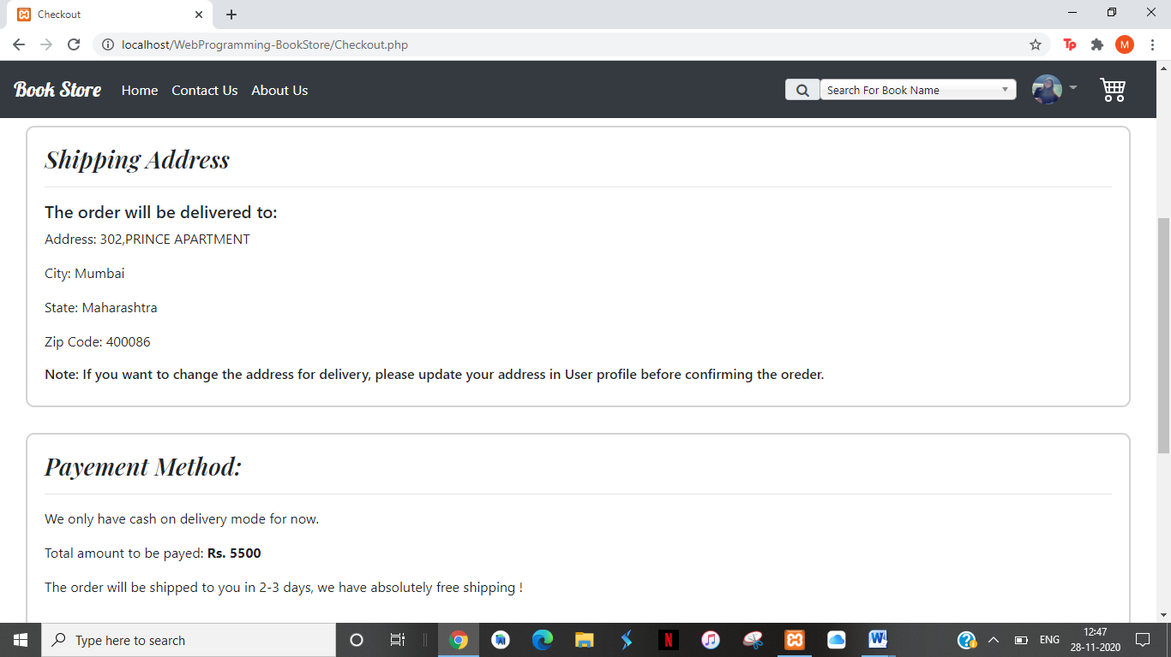

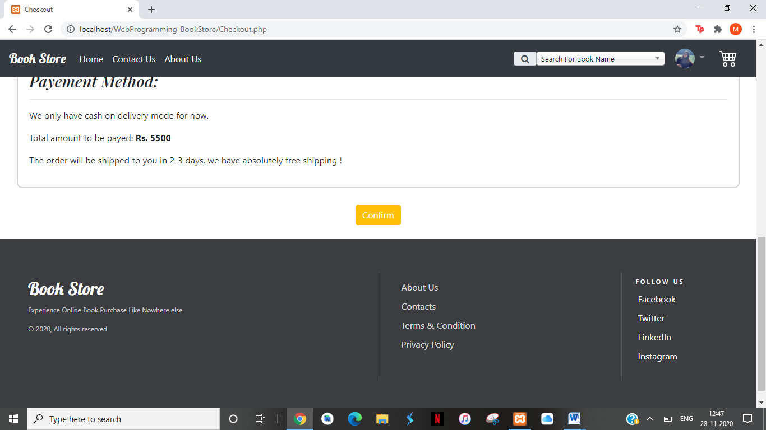

On clicking confirm:

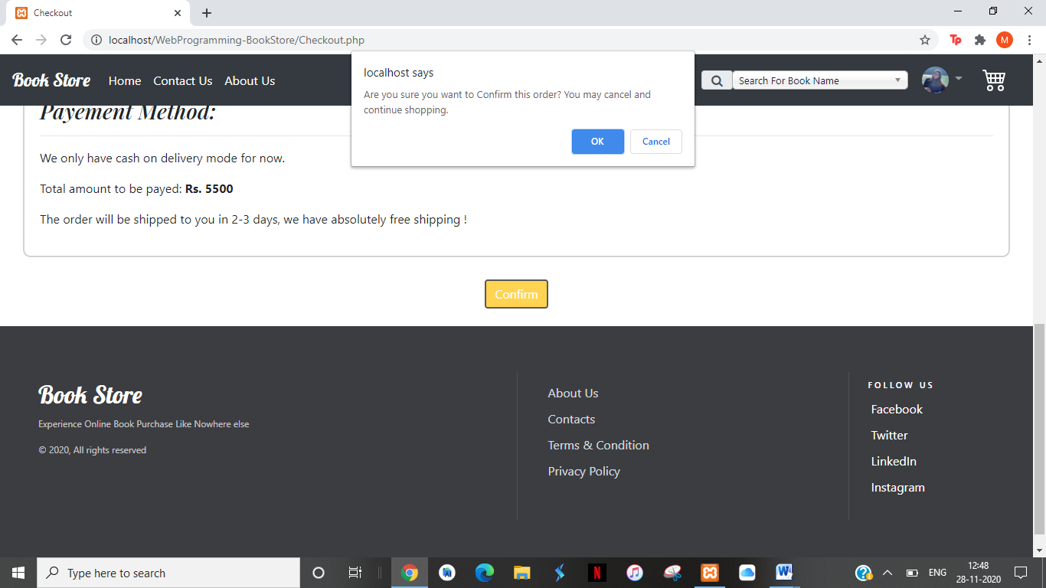

On clicking confirm , Thank You message is printed and you are directed back to Home Page

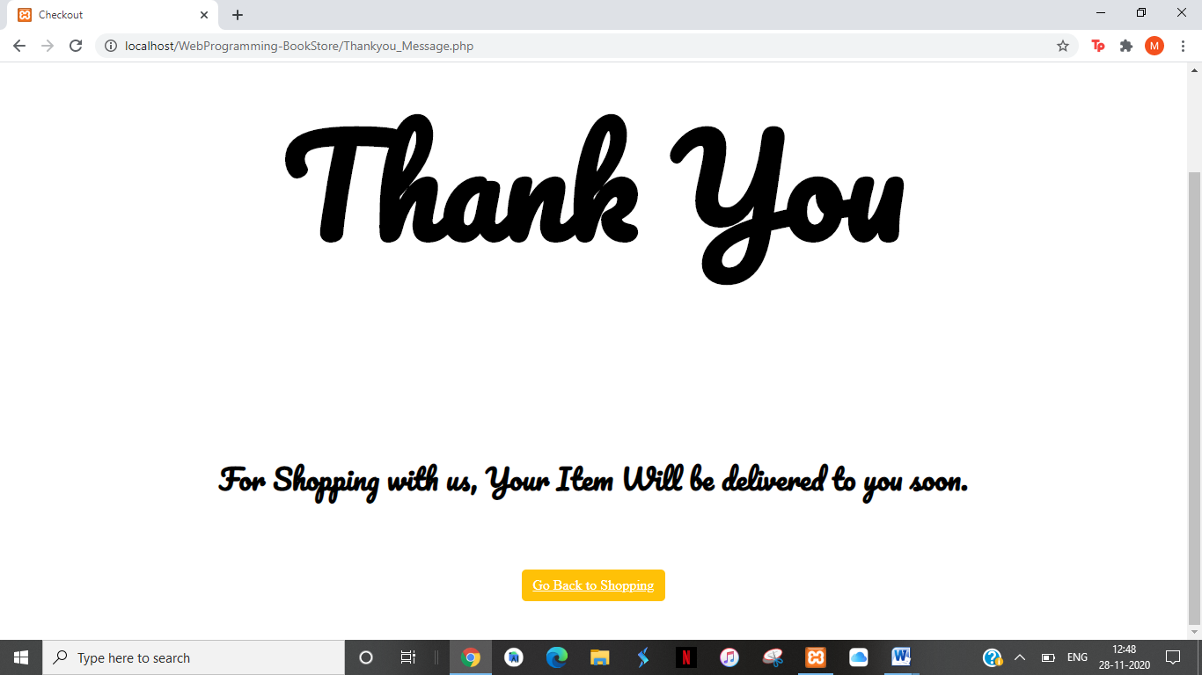

## AboutUs.php

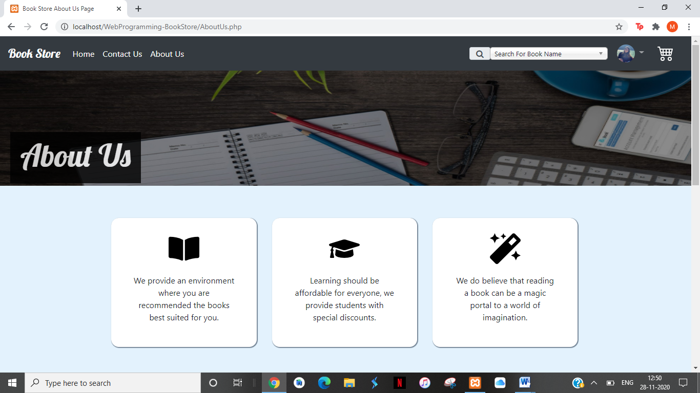

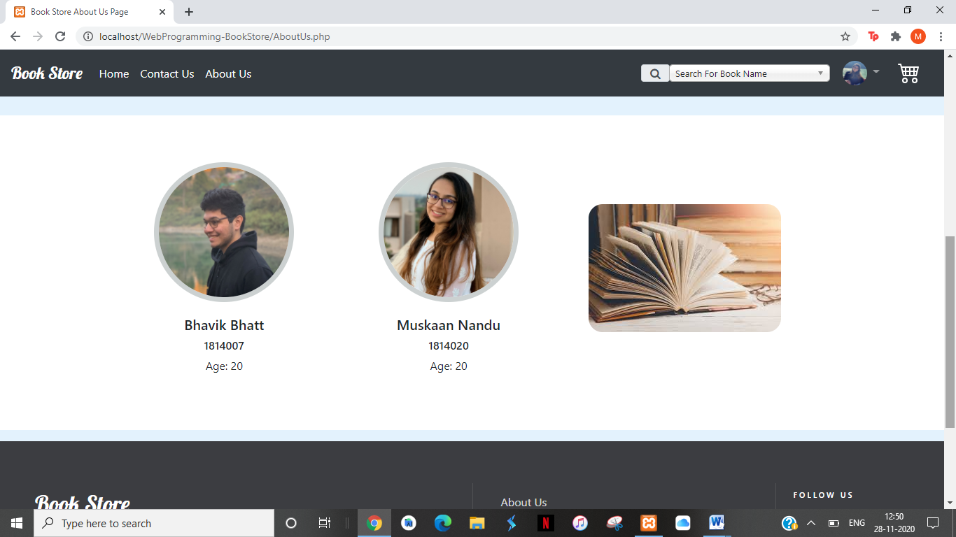

## Contact Us

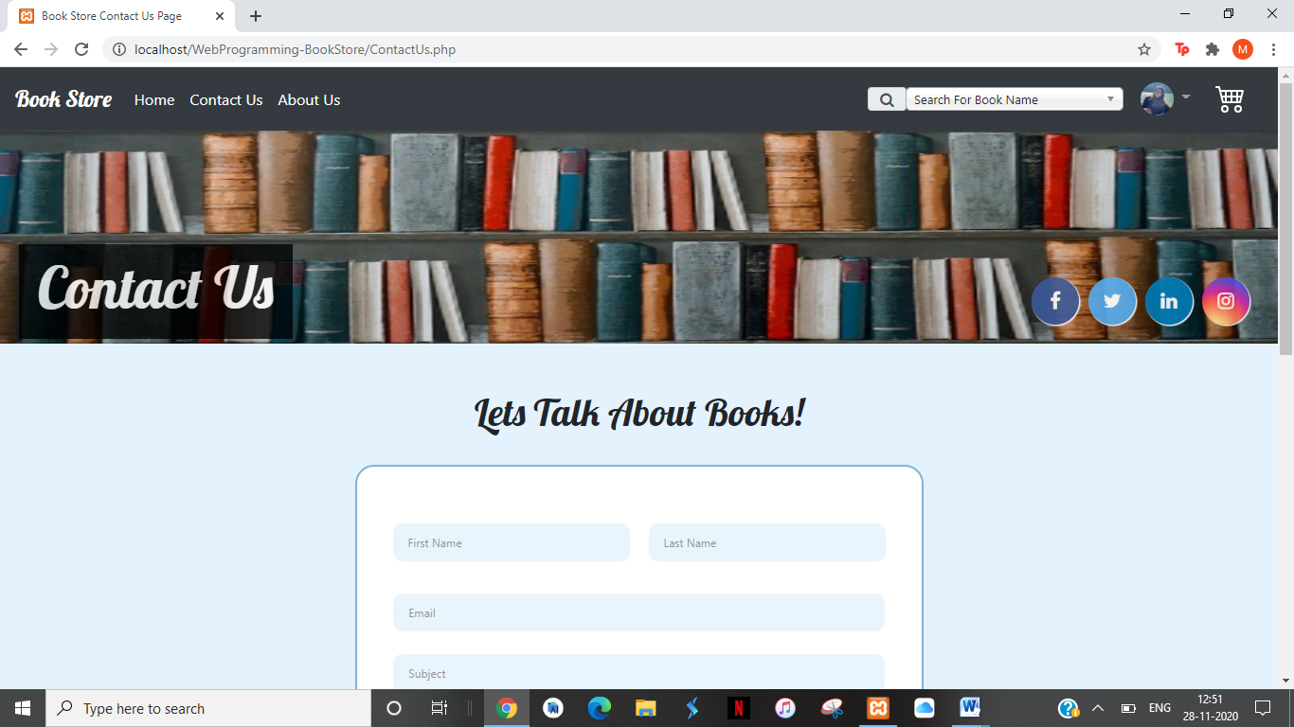

Validation is applied to all fields

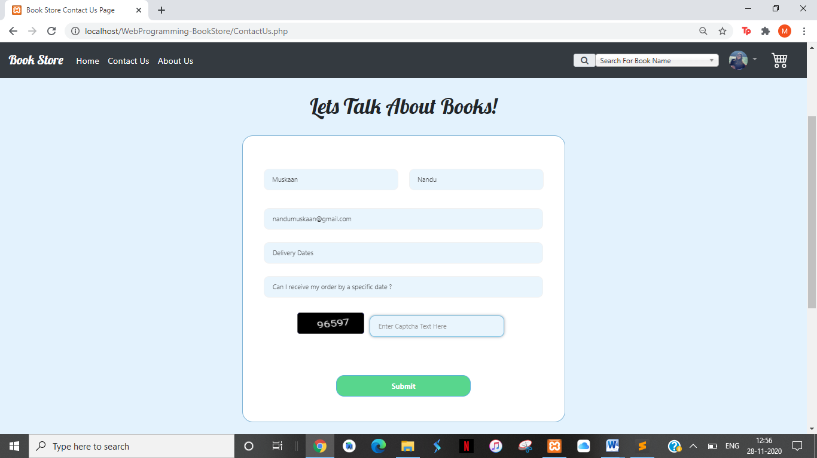

We have added captcha to avoid spams by automated bots.

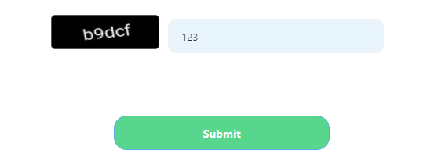

On Clicking Submit:

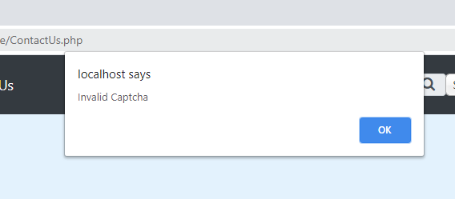

On entering Valid Captcha:

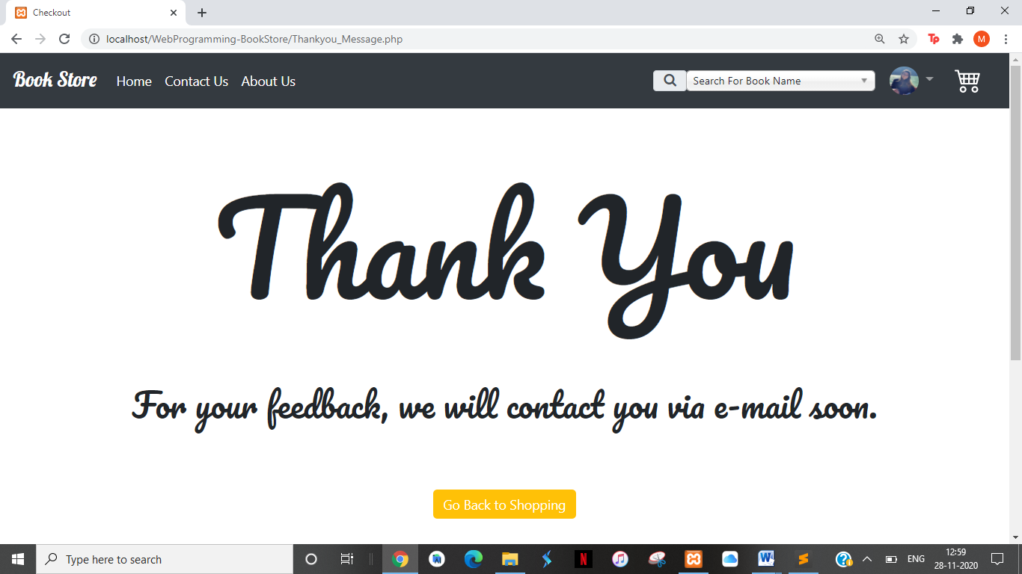

## Admin Login

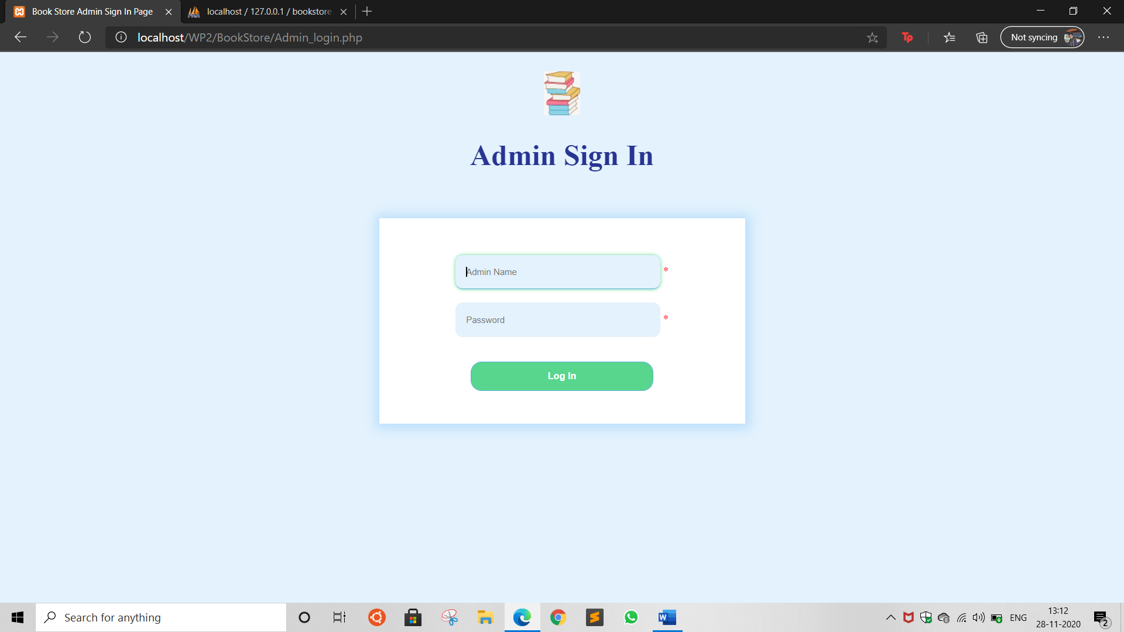

Validation in admin sign in

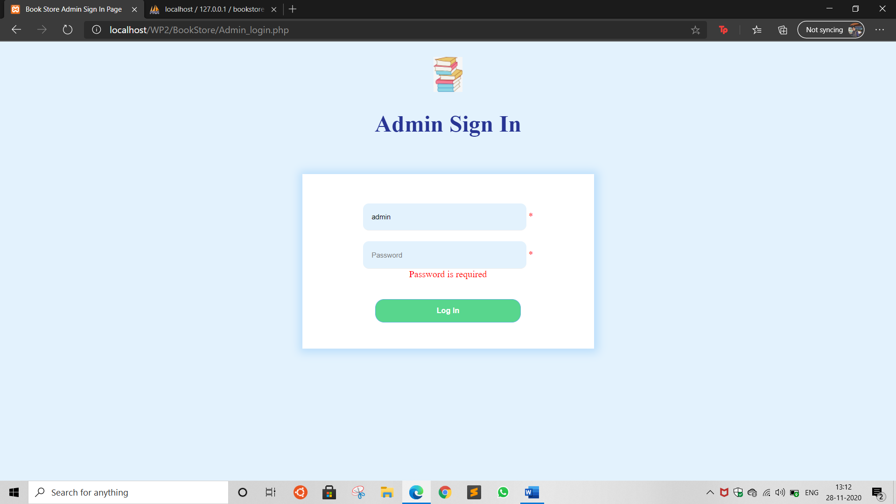

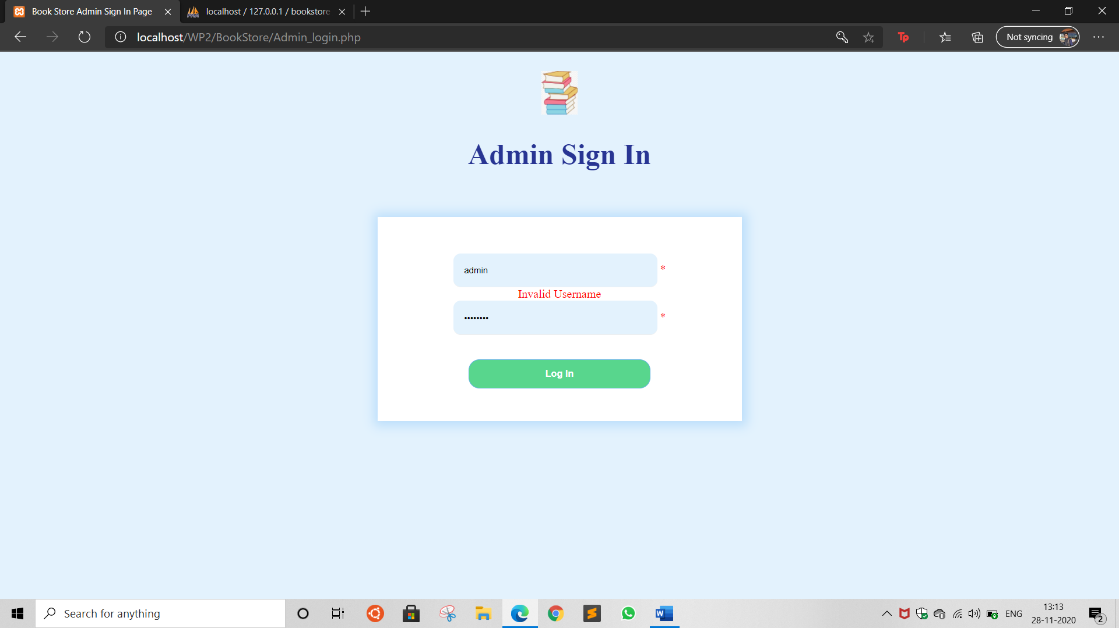

On successful credentials:

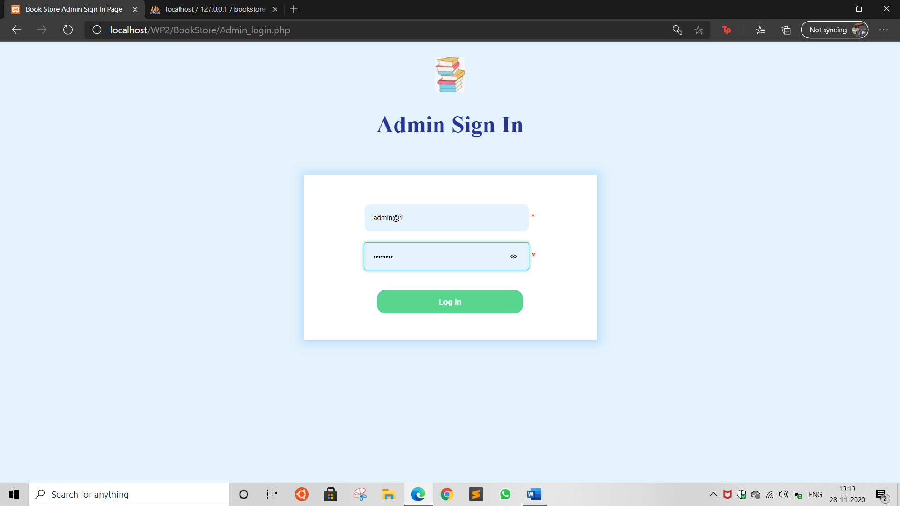

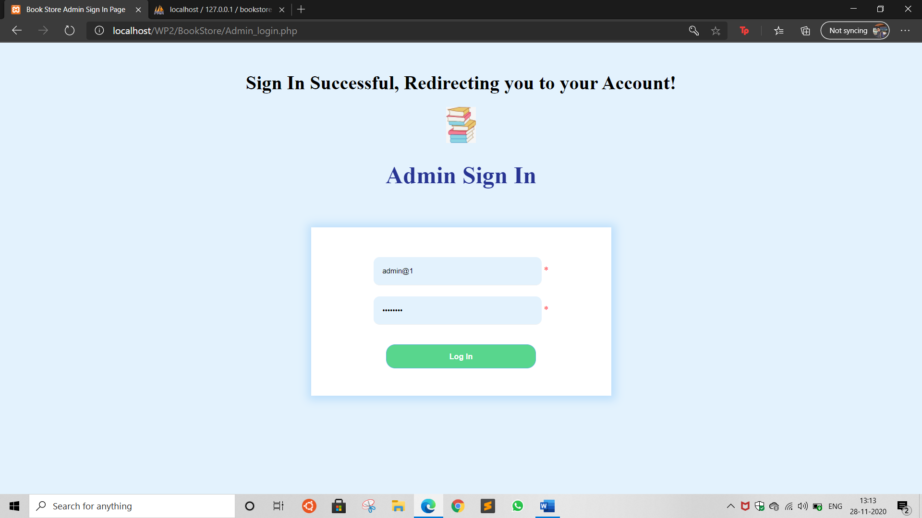

## Admin Home

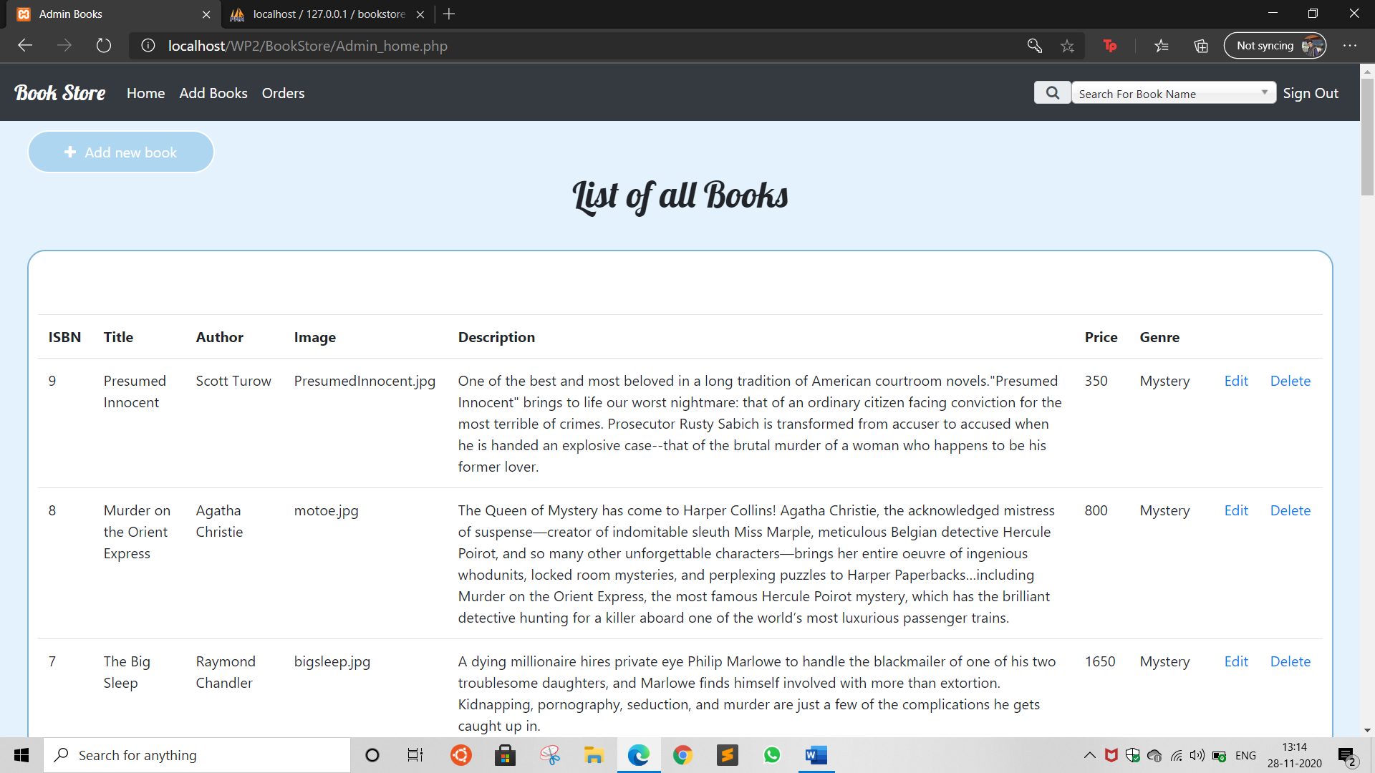

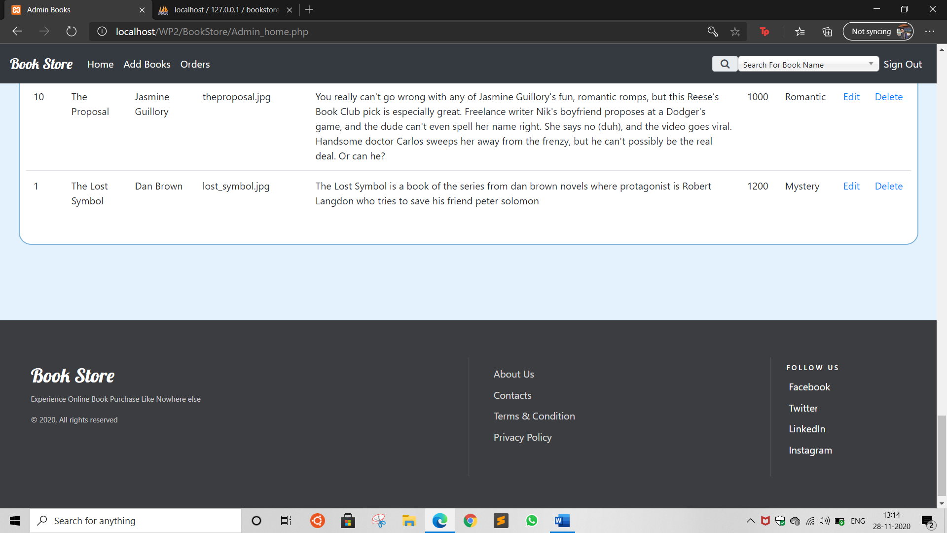

## Admin Add book

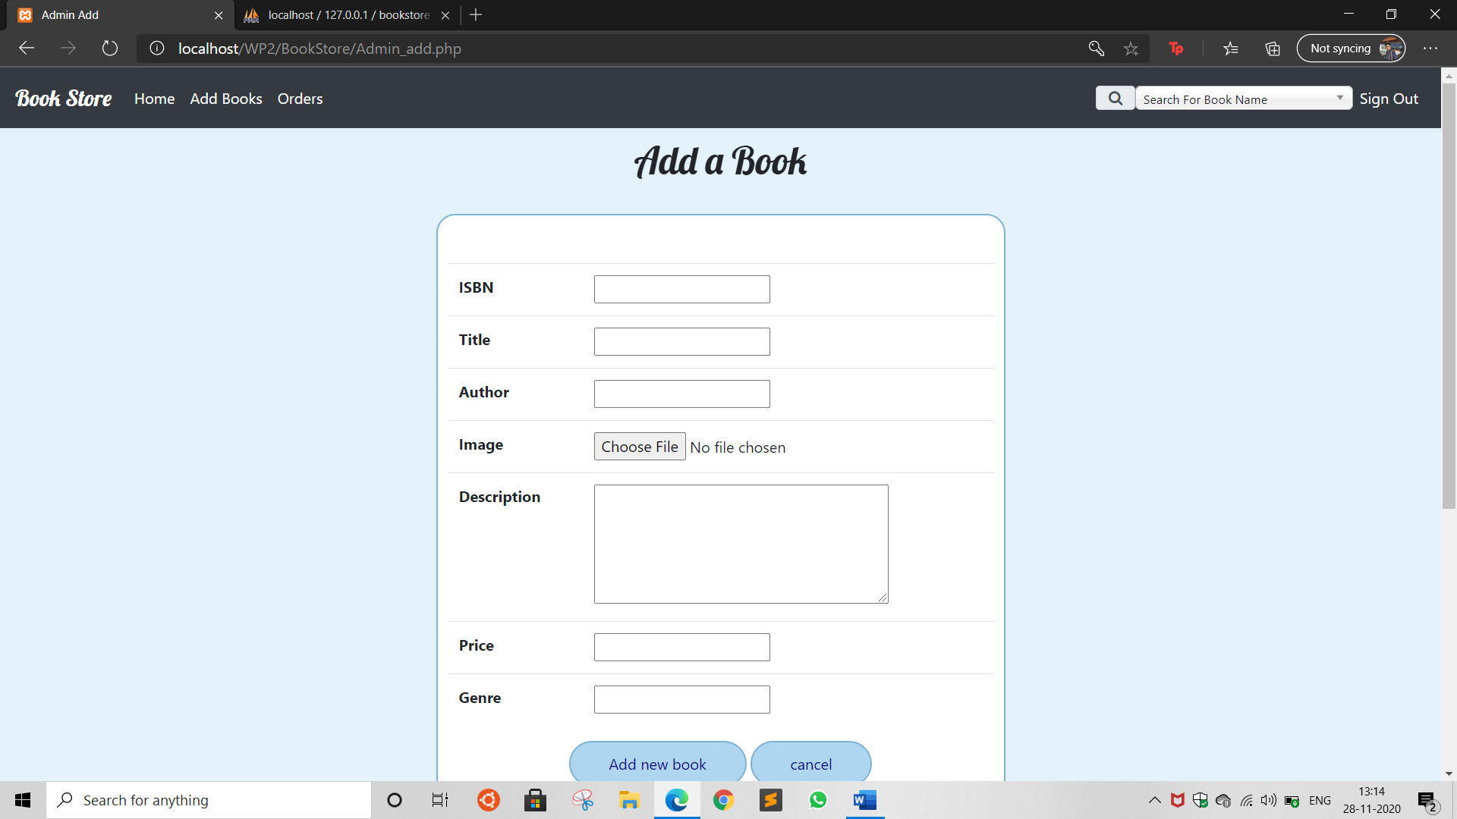

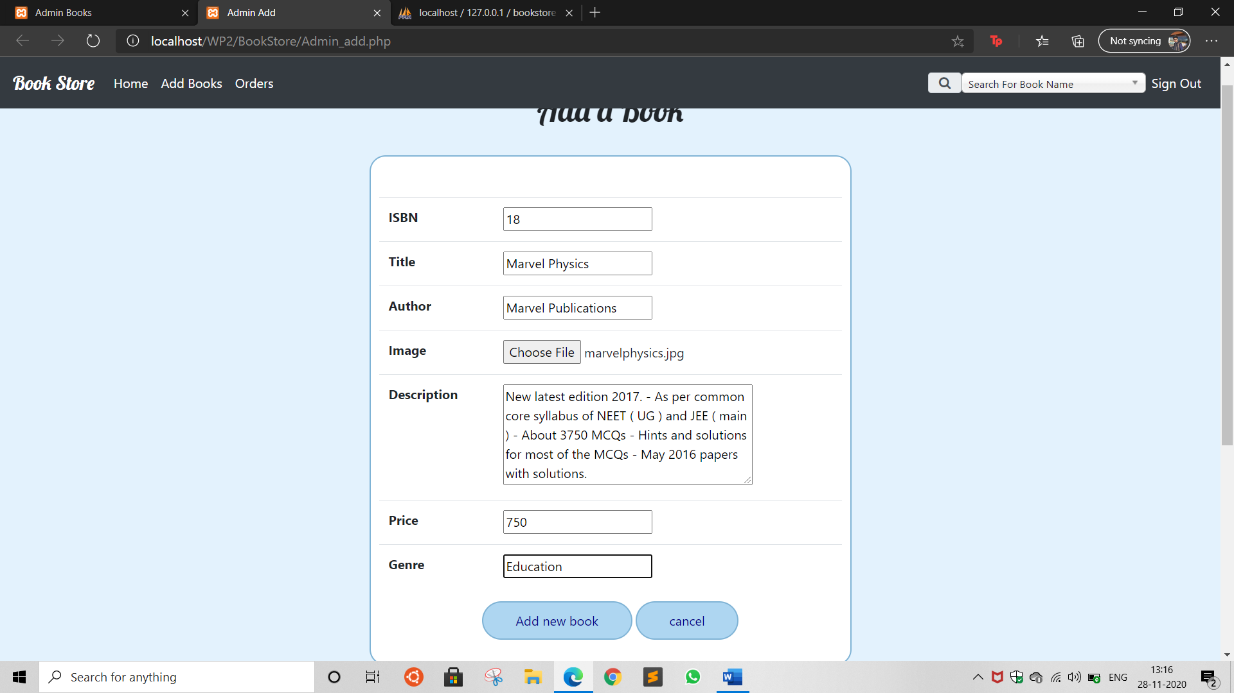

Book added to list of books:

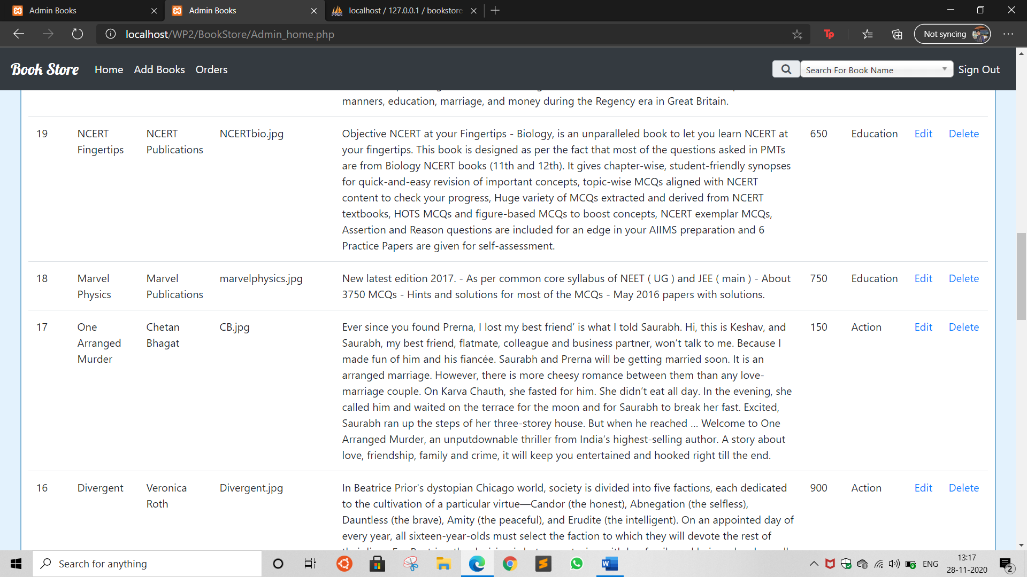

## Admin Edit

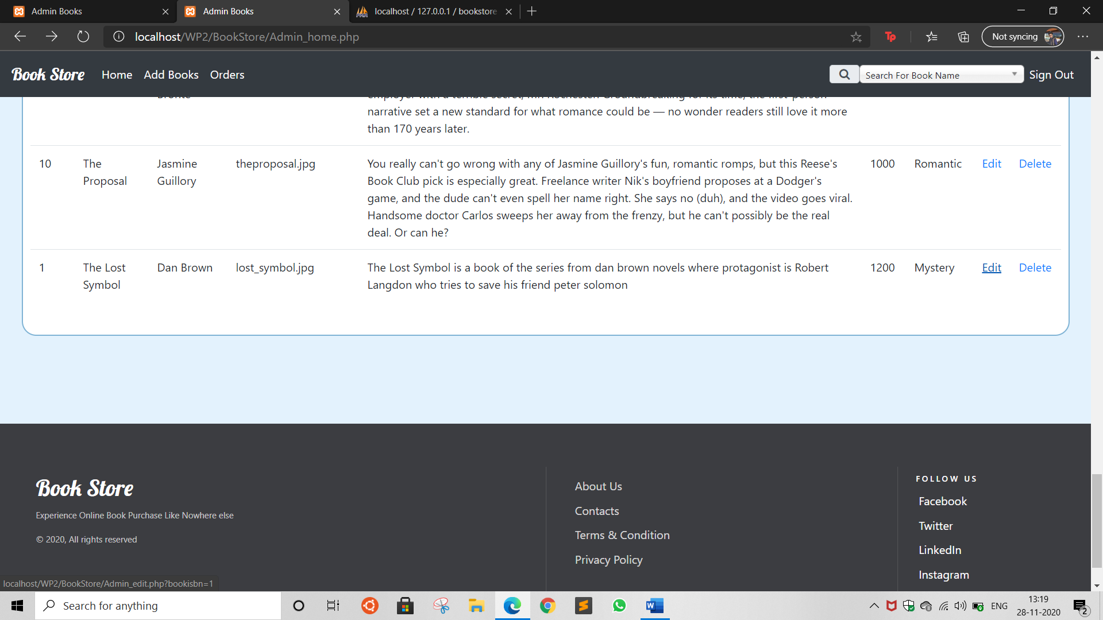

Initial Data:

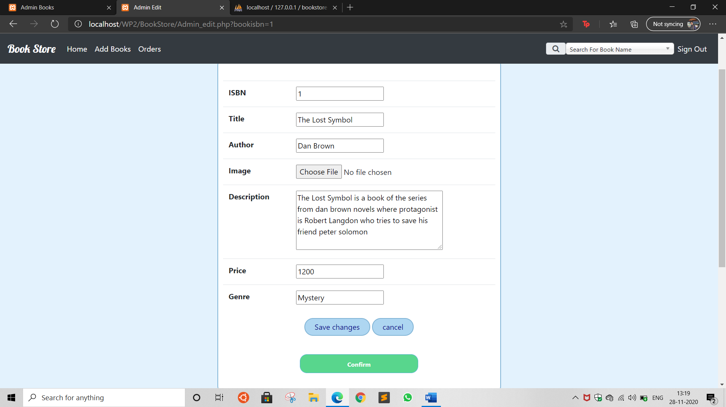

Price changed to 1500

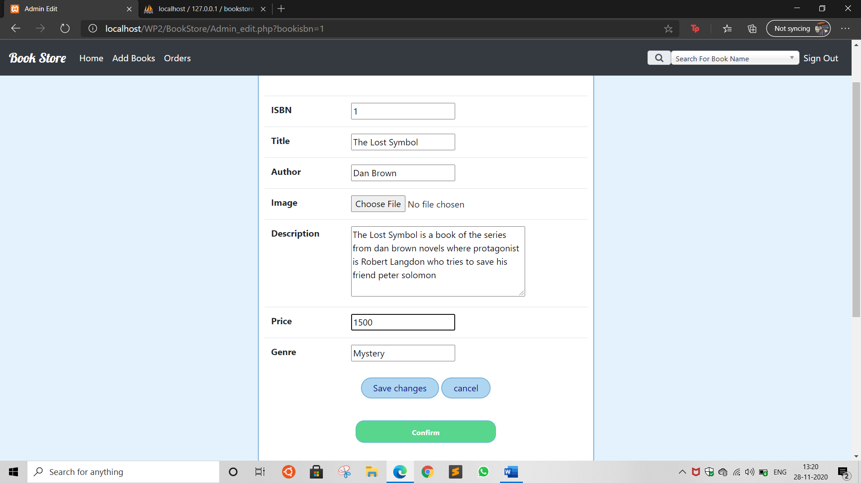

Changes Reflected

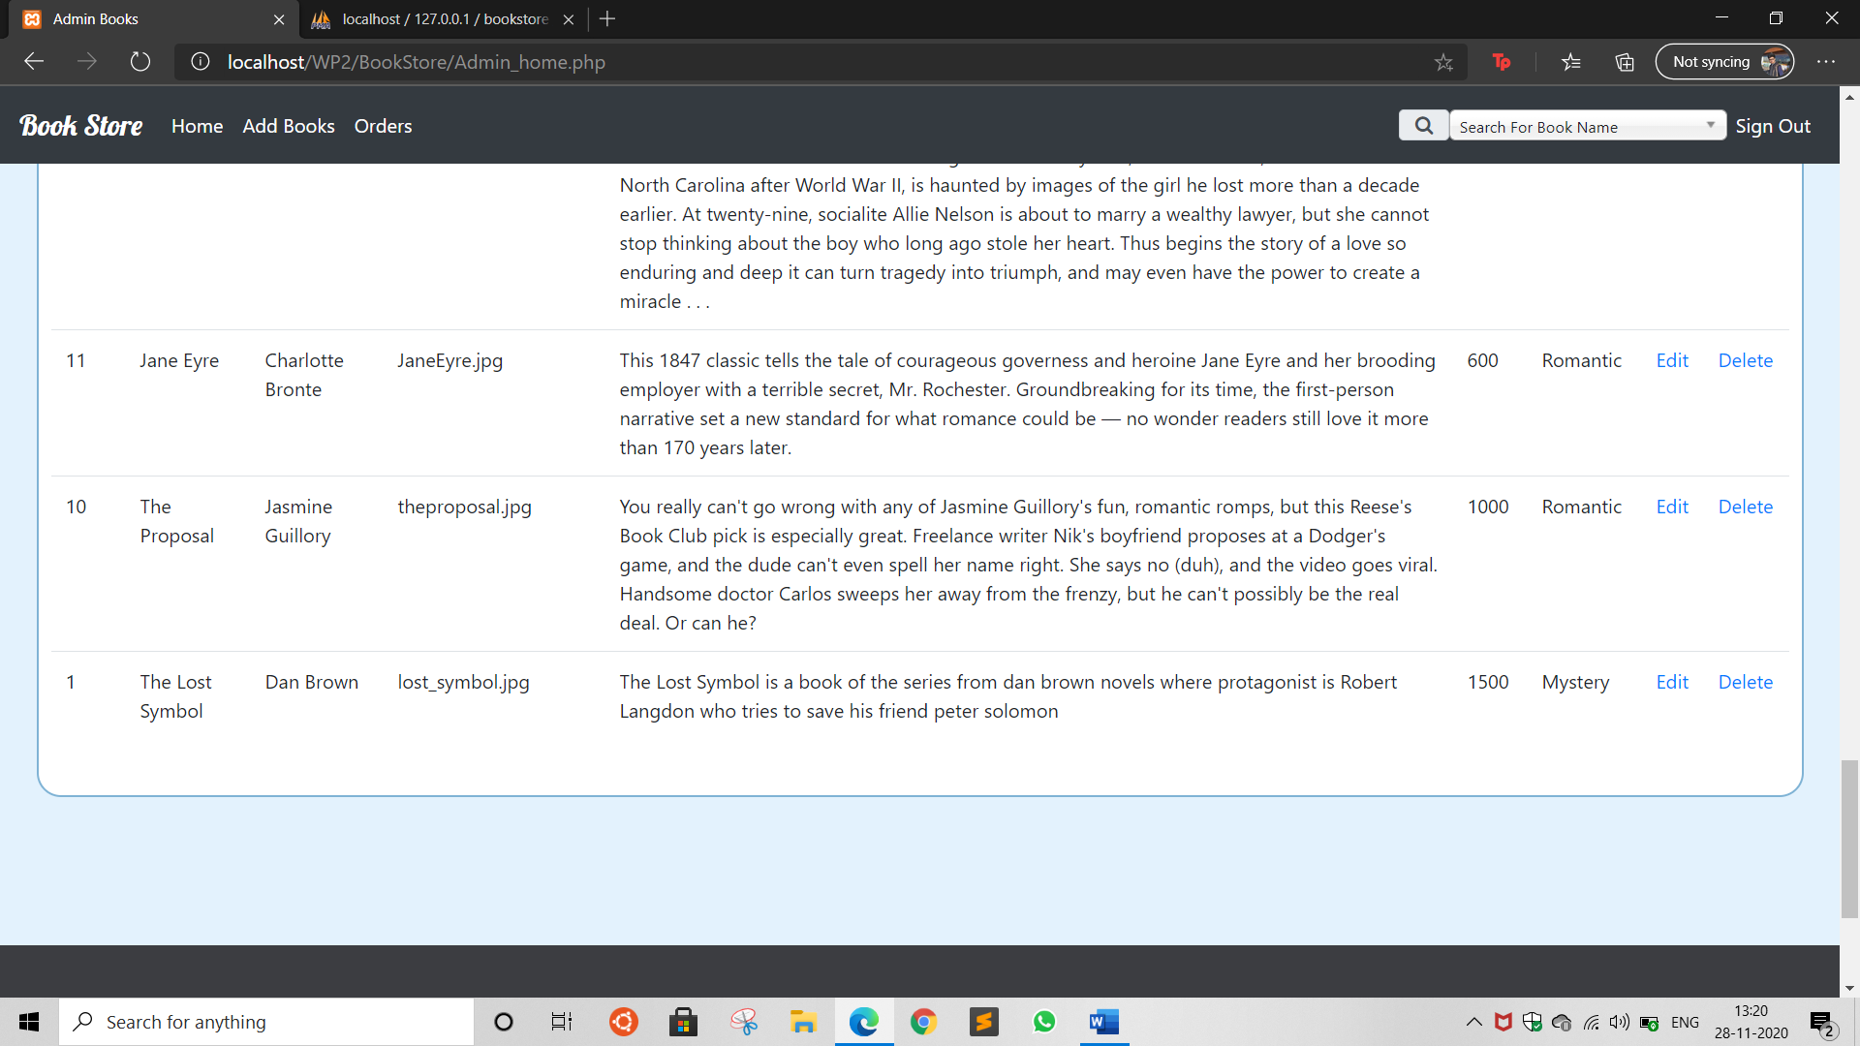

## Admin Delete

Deleting the book “the lost symbol”

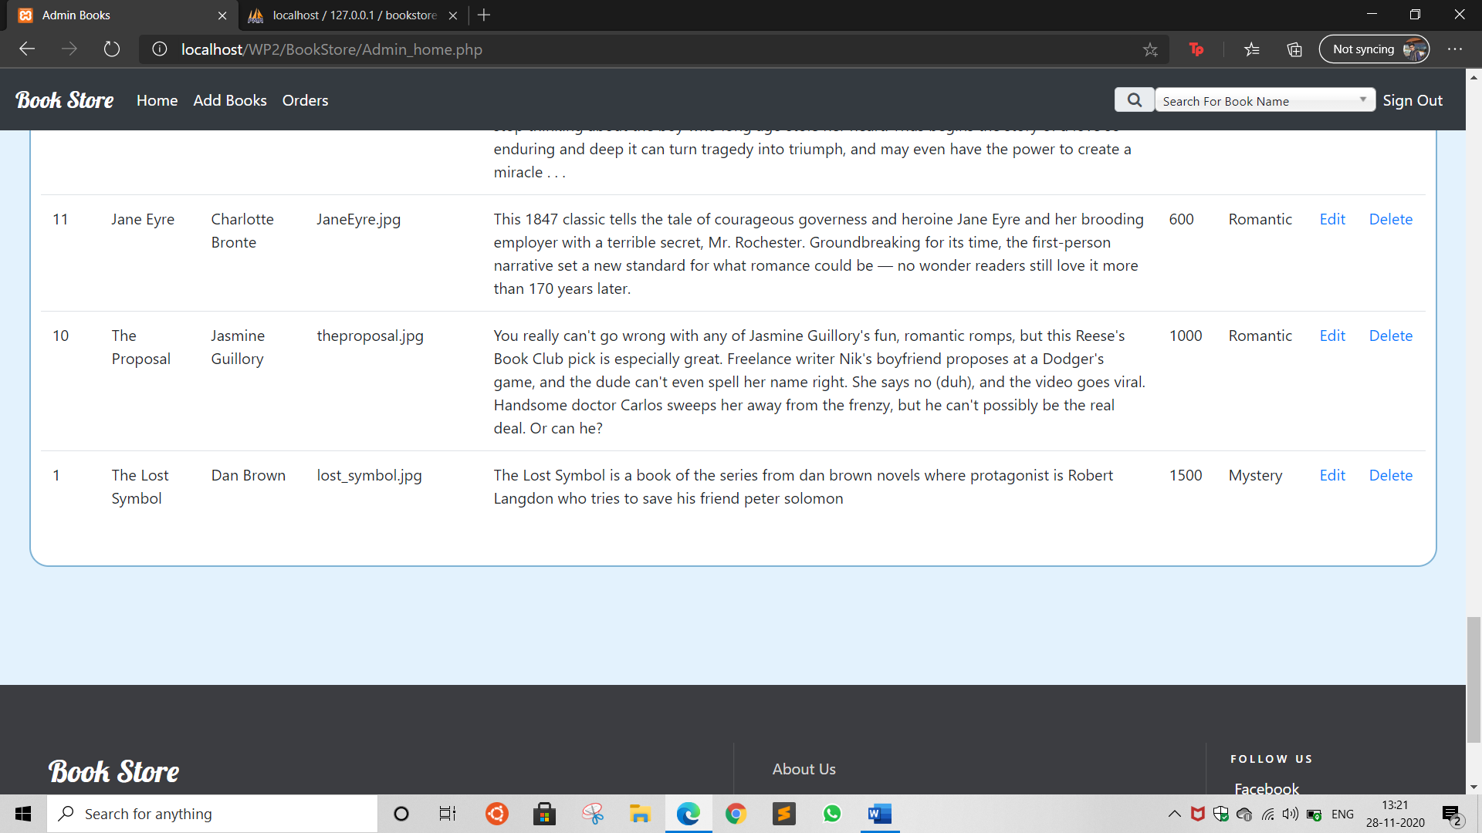

After deleting

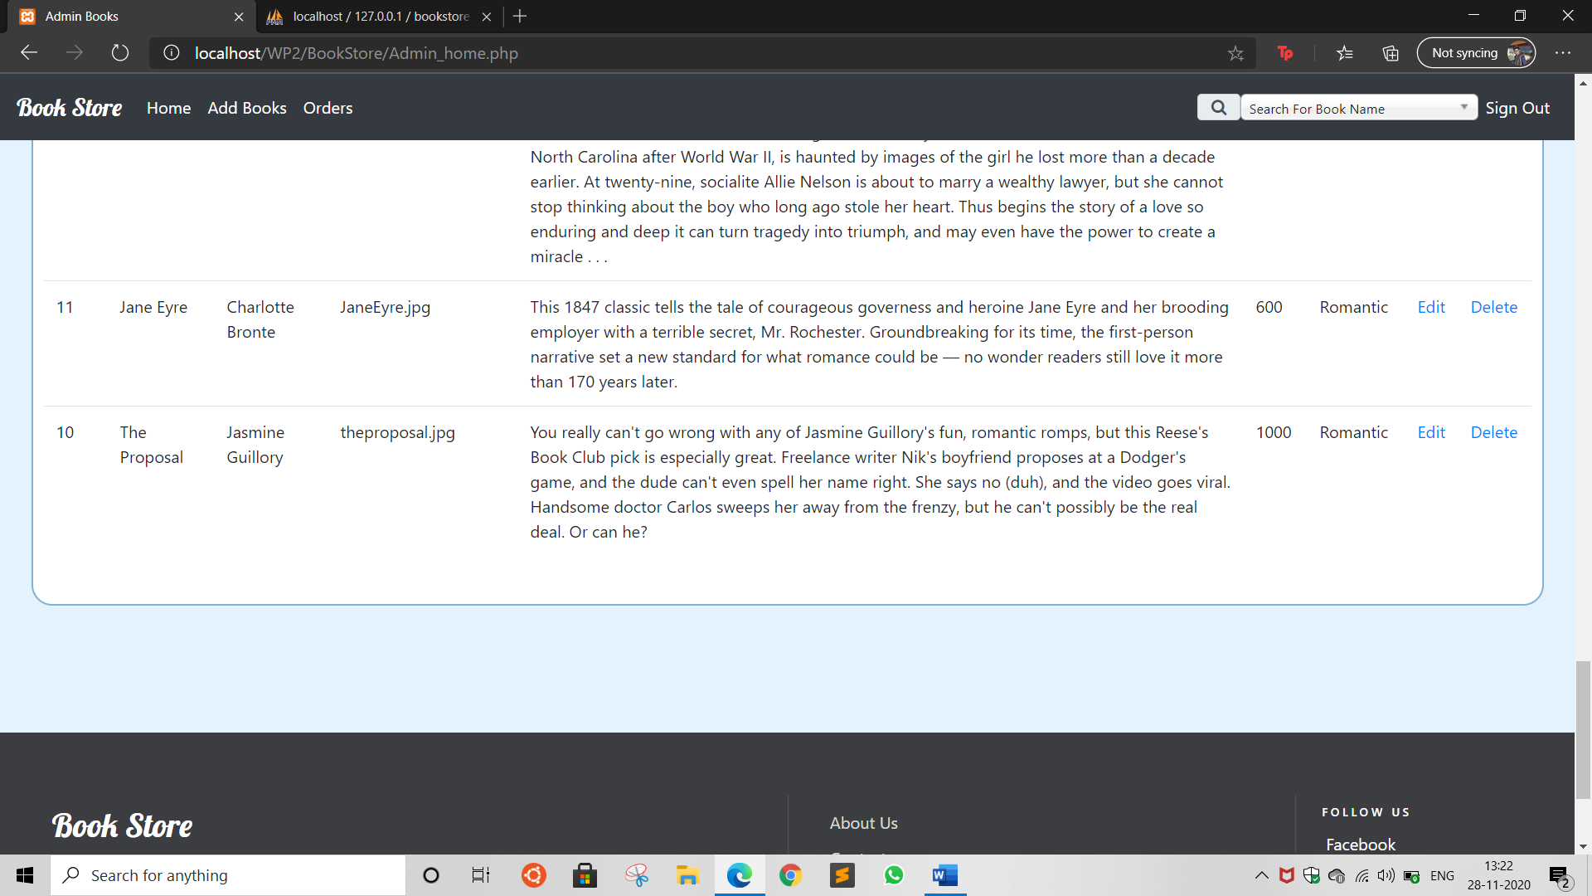

## Admin Order

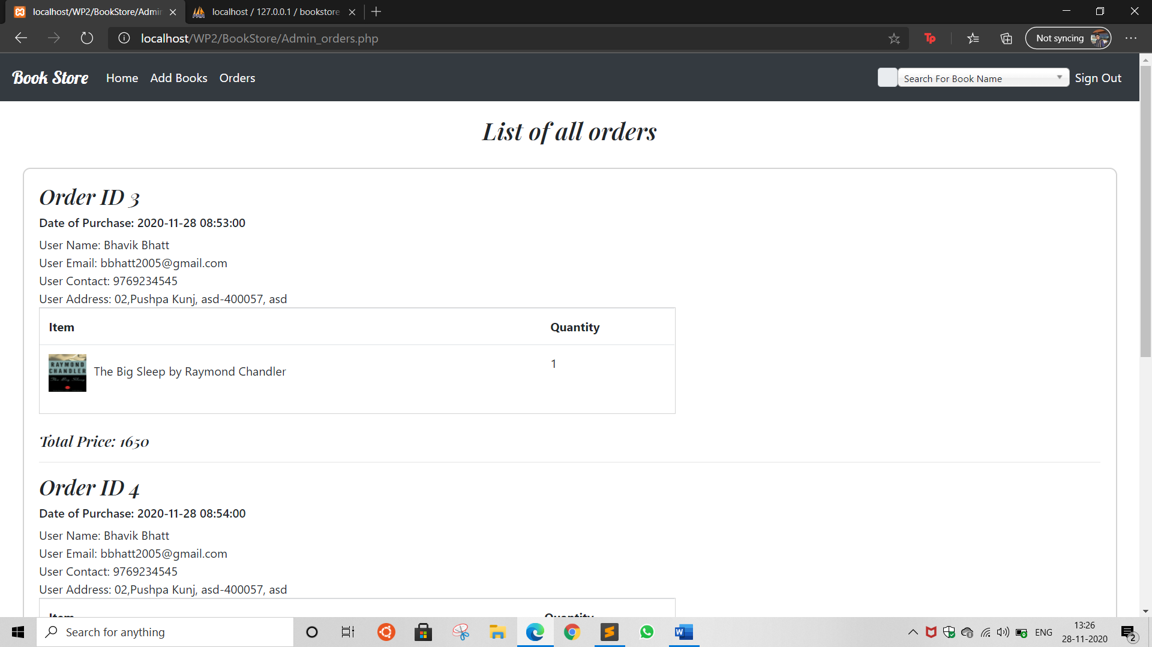

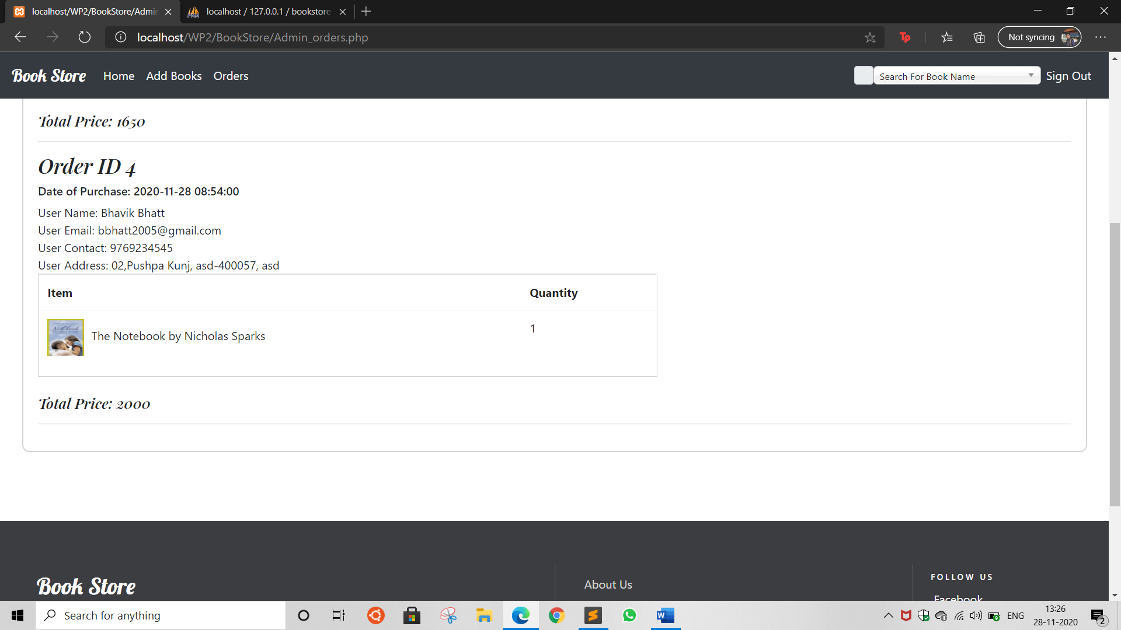

## Admin Search Bar

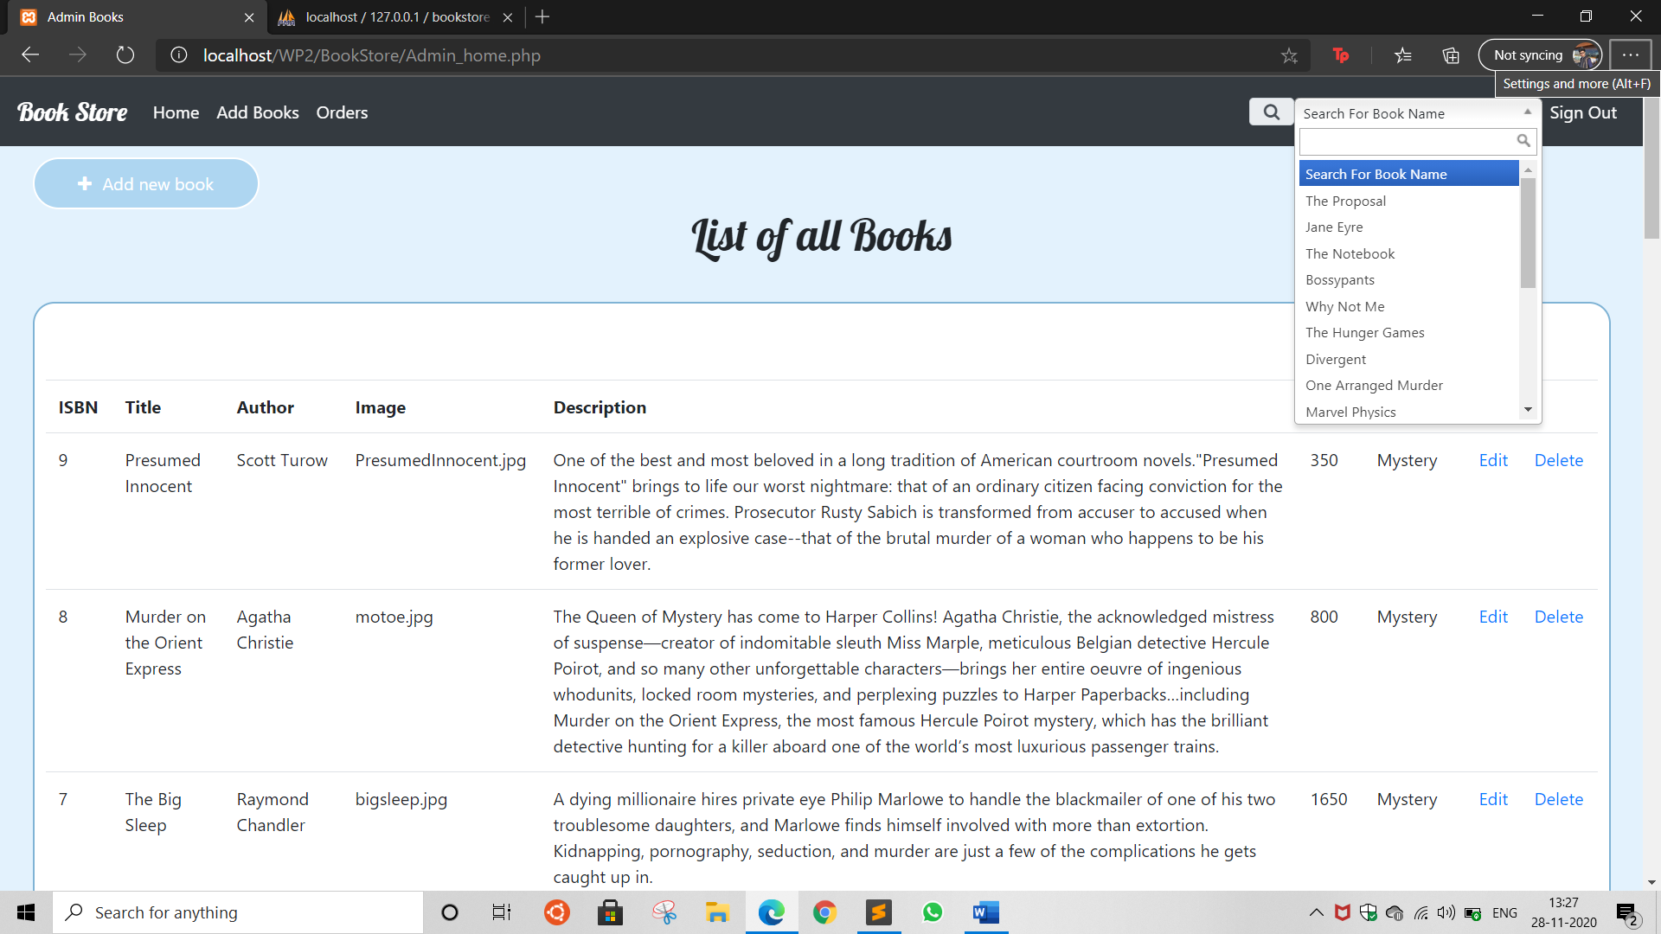

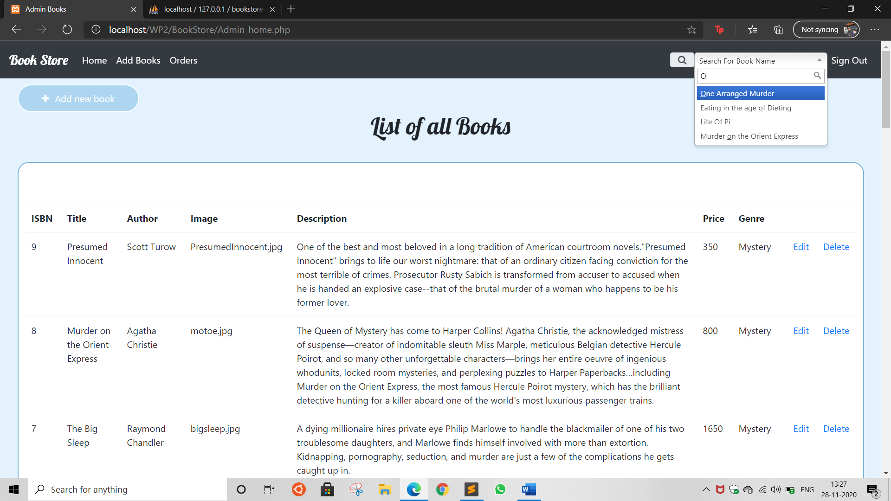

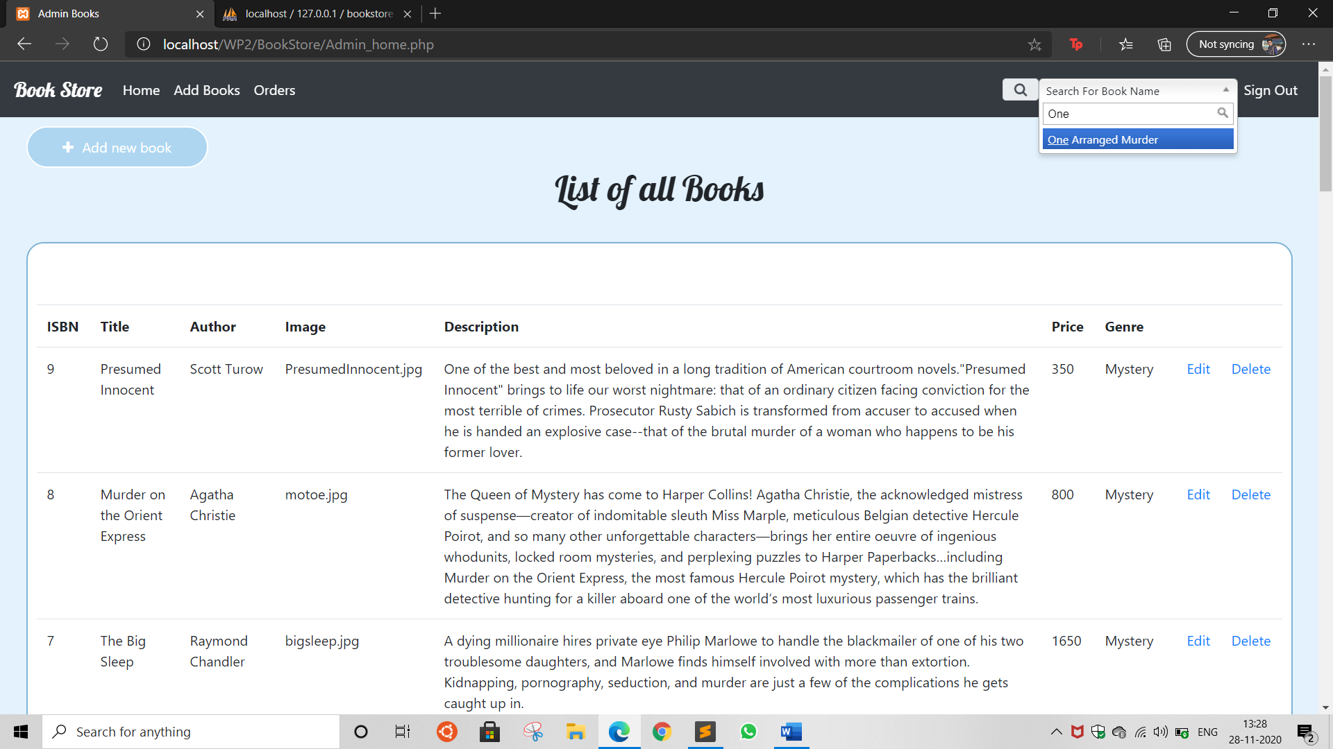

Selecting a book takes admin to details of that book

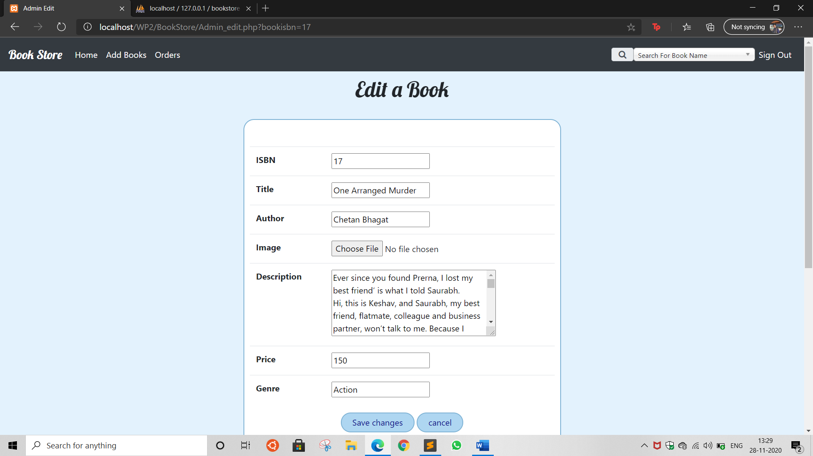

## Admin Sign Out

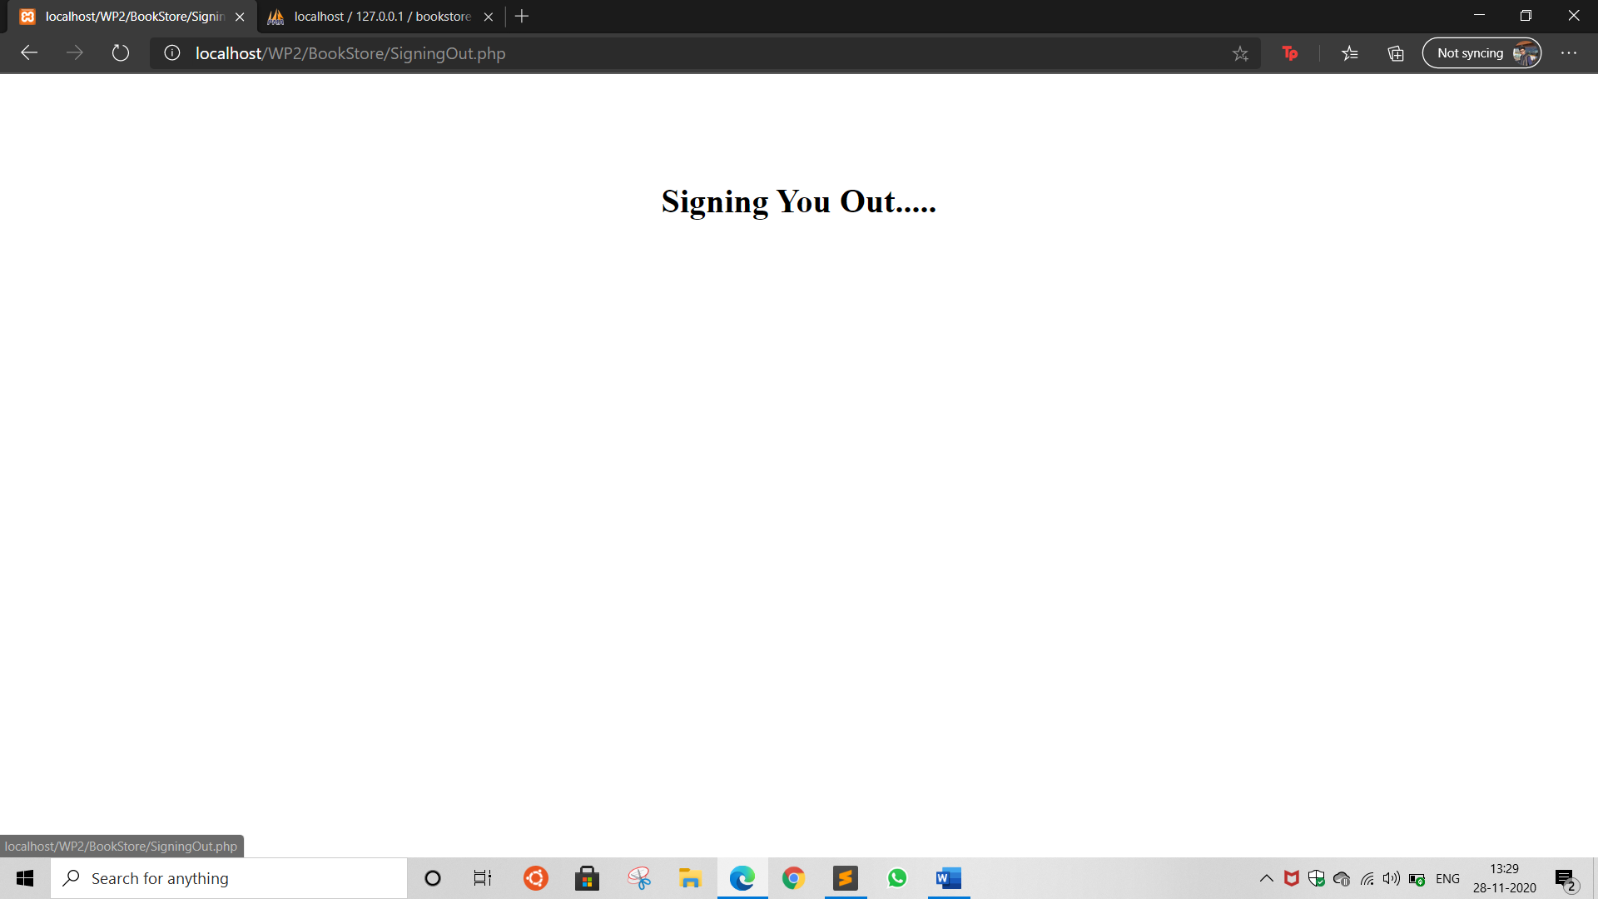

Outcome:

CO1: Illustrate use of basic PHP concepts to develop applications

CO2: Design forms and use session handling mechanism with web applications

CO3: Carry out database operations using PHP

CO4: Demonstrate the use advanced features such as REST API, email handling,

localization and internationalization in PHP

Summary:

Thus, this Mini Project wherein we developed an online BookStore helped us in understanding various concepts of PHP to depths and helped us explore and learn different elements, features and functions of PHP as required by the project, ensuring its proper, smooth and optimal performance. Using PHP along with HTML, CSS and JAVASCRIPT helped us reach the pith of our topic and we were able to transform our project from its rudimentary state to its absolute, intended and purposeful state which is an online BookStore that helps users buy books online without the hassle of going to a physical book store during these tough times.

Grade: AA / AB / BB / BC / CC / CD /DD

Signature of faculty in-charge with date References:

1. UI elements: <https://getbootstrap.com/>
2. Array in database : <https://stackoverflow.com/questions/8641889/how-to-use-php-serialize-and-unserialize>

3. File handling: <https://www.w3schools.com/php/php_file.asp>

4. Captcha: <https://youtu.be/1_JTAMfddIg>



5. Few PHP elements from : <https://www.php.net/manual/en/index.php>